Removing the Borders from a Table
Frank Schneemann

The first thing that must be done is to select the table you want to remove the lines from  - Place the cursor anywhere inside the table | 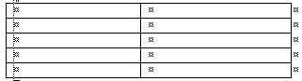
- Click the Table Menu  - Click Select  - Click Table  This will select (highlight) the enter table  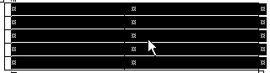 | 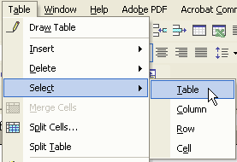
Now that the table is selected  - Click the Format Menu  - Click Borders and Shading | 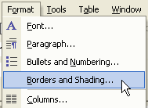

The Window on the right will open  - Click None | 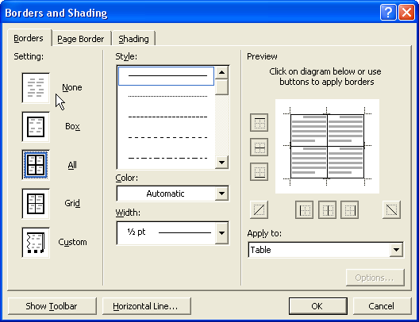
Faint lines will now show where the borders were but the borders will not print  - Click Print Preview to see how your borders will show when you print |  | 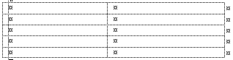

An Alternate Method for Removing Borders

- Place your cursor in the table and select the table as you did  - Click the litter down arrow next to the Borders Icon  - Select the type or border you want  Just remember to select the table first then apply the type of border. | 