7.6.1: Skills Integration Challenge-Data Link Layer Issues

Topology Diagram
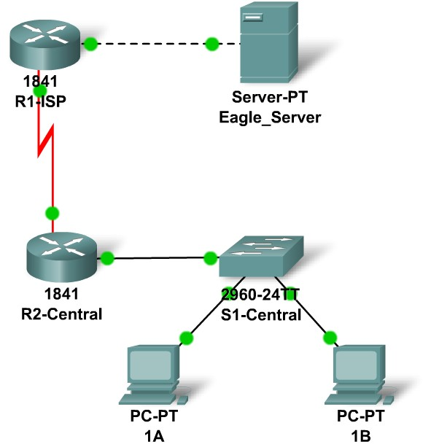

Addressing Table
Device | Interface | IP Address | Subnet Mask |  | Default Gateway
R1-ISP | Fa0/0 |  |  |  | N/A
R1-ISP | S0/0/0 |  |  |  | N/A
R2-Central | Fa0/0 |  |  |  | N/A
R2-Central | S0/0/0 |  |  |  | N/A
PC 1A | NIC
PC 1B | NIC
Eagle Server | NIC

Learning Objectives
- IP subnet planning
  - Practice your subnetting skills.
- Build the network.
  - Connect devices with Ethernet and serial cables.
- Configure the network.
  - Apply your subnetting scheme to server, PCs, and router interfaces; configure services and static routing.
- Test the network
  - Using ping, trace, web traffic, Inspect tool.

Background
Network Interface Cards (NICs) are sometimes thought of as Layer 2 and Layer 1 devices (or as Layer 2 and Layer 1 components of devices that function at all 7 layers). Sometimes the network interface card for a serial connection, typically used in WAN connections, is called a WAN interface card or WIC. In this challenge you must add a WIC to a device to complete the network. In addition, you have been asked to implement a new IP addressing scheme to the Exploration lab topology.

Task 1: IP Subnet Planning.
You have been given an IP address block of 172.16.0.0 /22. You must provide for existing networks as well as future growth.
Subnet assignments are:
- 1st subnet, existing student LAN, up to 400 hosts; (Fa0/0 on R2-Central)
- 2nd subnet, future student LAN, up to 180 hosts; (not yet implemented)
- 3rd subnet, existing ISP LAN, up to 40 hosts; (Fa0/0 on R1-ISP)
- 4th subnet, future ISP LAN, up to 18 hosts; (not yet implemented)
- 5th subnet, existing WAN, point-to-point link; (S0/0/0 on R1-ISP and R2-Central)
- 6th subnet, future WAN, point-to-point link; (not yet implemented)
- 7th subnet, future WAN, point-to-point link. (not yet implemented)
Interface IP addresses:
- For the server, configure the second highest usable IP address on the ISP LAN subnet.
- For R1-ISP's Fa0/0 interface, configure the highest usable IP address on the ISP LAN subnet.
- For R1-ISP's S0/0/0 interface, configure the highest usable address on the existing WAN subnet.
- For R2-Central's S0/0/0 interface, use the lowest usable address on the existing WAN subnet.
- For R2-Central's Fa0/0 interface, use the highest usable address on the existing student LAN subnet.
- For PCs 1A and 1B, use the first 2 IP addresses (two lowest usable addresses) on the existing student LAN subnet.
Additional configurations:
- For PCs 1A and 1B, in addition to IP configuration, configure them to use DNS services.
- For the server, enable DNS services, use the domain name eagle-server.example.com, and enable HTTP services.

Task 2: Finish Building the Network in Packet Tracer, Attending to Some Layer 2 Issues.
On the R2-Central router, a network interface card is missing for the serial connection to R1-ISP: add a WIC-2T in the right hand slot. Also, on R2-Central, the Fa0/0 is shutdown; turn it on. Connect a serial DCE cable to R1-ISP S0/0/0, with the other end to R2-Central S0/0/0. For all devices, make sure the power is on to all device and interfaces.

Task 3: Configure the Network.
You will need to configure the server, both routers, and the two PCs. You will not need to configure the switch nor do you need the IOS CLI to configure the routers. Part of the router configuration has already been done for you: all you must do is configure the static routes and the interfaces via the GUI. The static route on R1-ISP should point to the existing student LAN subnet via R2-Central's serial interface IP address; the static route on R2-Central should be a default static route which points via R1-ISP's serial interface IP address. These procedures were explained in the Chapter 5 Skills Integration Challenge and practiced in the Chapter 6 Skills Integration Challenge.

Task 4: Test the Network.
Use ping, trace, web traffic, and the Inspect tool. Trace packet flow in simulation mode, with HTTP, DNS, TCP, UDP, and ICMP viewable, to test your understanding of how the network is operating. Note in particular what Layer 2 encapsulation is used in each step of a packet's journey, and how the headers on the Layer 2 PDUs change.

Reflection
Consider an ICMP echo request packet sent from PC 1A to Eagle Server and the ICMP echo reply packet that results. What addresses stay the same in this situation, and what addresses change?

