10.7.1: Skills Integration Challenge: Network Planning and Interface Configuration

Topology Diagram

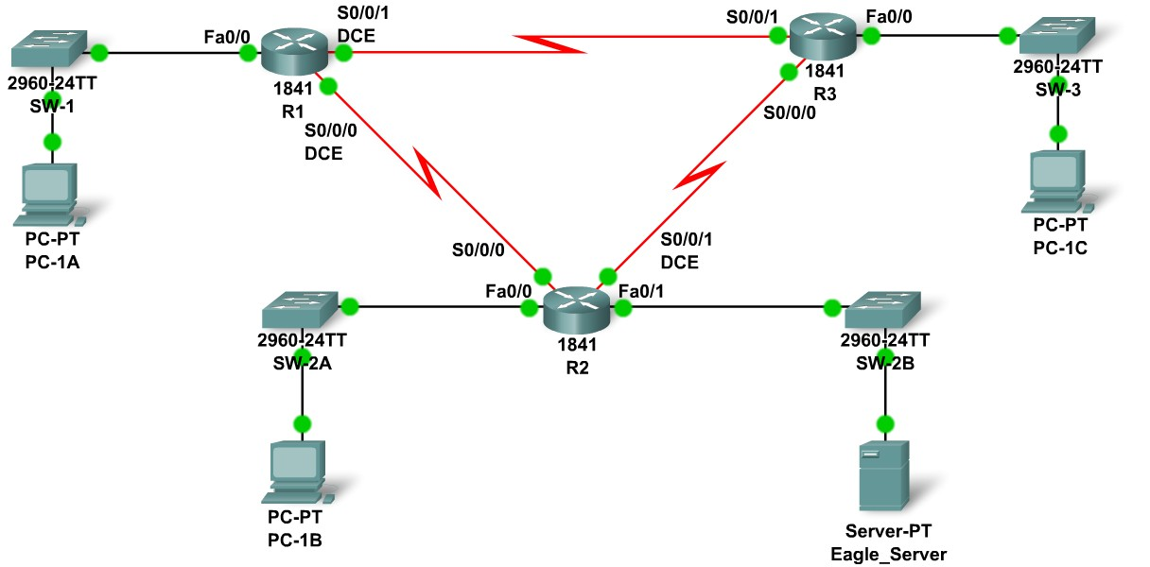

Addressing Table
Device | Interface | IP Address | Subnet Mask | Default Gateway
R1 | Fa0/0 |  |  | N/A
R1 | S0/0/0 |  |  | N/A
R1 | S0/0/1 |  |  | N/A
R2 | Fa0/0 |  |  | N/A
R2 | Fa0/1 |  |  | N/A
R2 | S0/0/0 |  |  | N/A
R2 | S0/0/1 |  |  | N/A
R3 | Fa0/0 |  |  | N/A
R3 | S0/0/0 |  |  | N/A
R3 | S0/0/1 |  |  | N/A
PC-1A | NIC
PC-2A | NIC
PC-3A | NIC
Eagle_Server | NIC

Learning Objectives
Upon completion of this lab, you will be able to:
- Build the network topology.
- Plan the IP addresses.
- Configure router and PC interfaces.
- Test the network.

Background
Practice your network building, planning, and configuration skills. Device names and routing have already been configured.

Task 1: Build the Network Topology.
Use the following charts, and the devices in the Device Pool, to create the topology.
Routers:
Hostname | Interface | Connects To | Interface
R1 | Fa0/0 | SW-1 | Fa0/1
R1 | S0/0/0 (DCE) | R2 | S0/0/0
R1 | S0/0/1 (DCE) | R3 | S0/0/1
R2 | Fa0/0 | SW-2A | Fa0/1
R2 | S0/0/1 (DCE) | R3 | S0/0/0
R2 | Fa0/1 | SW-2B | Fa0/1
R3 | Fa0/0 | SW-3 | Fa0/1

Switches:
Hostname | Interface | Connects To | Interface
SW-1 | Fa0/2 | PC-1A | FastEthernet
SW-2A | Fa0/2 | PC-1B | FastEthernet
SW-2B | Fa0/2 | Eagle_Server | FastEthernet
SW-3 | Fa0/2 | PC-1C | FastEthernet

Task 2: Create and Assign an Addressing Scheme.
You are asked to use the 192.168.1.0 /24 address space. Seven total networks are required; assign the networks in decreasing order of number of hosts required for efficient use of address space. Use the following charts to create an effective addressing scheme:
LAN:
Hostname | Interface | Number of Hosts
R1 | Fa0/0 | 60
R2 | Fa0/0 | 10
R2 | Fa0/1 | 30
R3 | Fa0/0 | 7

WAN:
Hostname | Address to be Assigned | Number of Hosts
R1-R2 | R1-First host address | 2
R1-R3 | R1-First host address | 2
R2-R3 | R2-First host address | 2
Use the following rules to assign the IP addresses.
- PCs will use the first host address in the subnet; the server will use the second to last host address in its subnet.
- All FastEthernet ports on a router will use the last host address of the assigned subnet.
- The R1-R2 link will use the first WAN subnet, the R1-R3 link will use the second WAN subnet, and the R2-R3 link will use the third WAN subnet. R1 and R2 DCE interfaces should have clock rates of 56000.

Task 3: Interface Configuration
Perform interface configuration of the R1, R2, and R3 routers, the PCs, and the server according to the addressing scheme above.

Task 4: Testing Connectivity
Make sure all PCs can ping their gateways, other PCs, and the server.

