Activity 6.7.4: IPv4 Address Subnetting Part 2

Learning Objectives
Upon completion of this activity, you will be able to determine subnet information for a given IP address and subnetwork mask.

Background
Borrowing Bits
How many bits must be borrowed to create a certain number of subnets or a certain number of hosts per subnet?
Using this chart, it is easy to determine the number of bits that must be borrowed.
Things to remember:
- Subtract 2 for the usable number of hosts per subnet, one for the subnet address and one for the broadcast address of the subnet.

2¹⁰ | 2⁹ | 2⁸ | 2⁷ | 2⁶ | 2⁵ | 2⁴ | 2³ | 2² | 2¹ | 2⁰
1,024 | 512 | 256 | 128 | 64 | 32 | 16 | 8 | 4 | 2 | 1
Number of bits borrowed:
10 | 9 | 8 | 7 | 6 | 5 | 4 | 3 | 2 | 1 | 1
1,024 | 512 | 256 | 128 | 64 | 32 | 16 | 8 | 4 | 2 | 1
Hosts or Subnets

Possible Subnet Mask Values
Because subnet masks must be contiguous 1’s followed by contiguous 0’s, the converted dotted decimal notation can contain one of a certain number of values:

Dec. | Binary
255 | 11111111
254 | 11111110
252 | 11111100
248 | 11111000
240 | 11110000
224 | 11100000
192 | 11000000
128 | 10000000
0 | 00000000

Scenario
When given an IP address, network mask, and subnetwork mask, you will be able to determine other information about the IP address such as:
- The subnet address of this subnet
- The broadcast address of this subnet
- The range of host addresses for this subnet
- The maximum number of subnets for this subnet mask
- The number of hosts for each subnet
- The number of subnet bits
- The number of this subnet
Task 1: For a Given IP Address and Subnet Mask, Determine Subnet Information.
Given:

Host IP Address | 172.25.114.250
Network Mask | 255.255.0.0 (/16)
Subnet Mask | 255.255.255.192 (/26)

Find:

Number of Subnet Bits
Number of Subnets
Number of Host Bits per Subnet
Number of Usable Hosts per Subnet
Subnet Address for this IP Address
IP Address of First Host on this Subnet
IP Address of Last Host on this Subnet
Broadcast Address for this Subnet

Step 1: Translate host IP address and subnet mask into binary notation.

IP Address | 172 | 25 | 114 | 250
IP Address | 10101100 | 11001000 | 01110010 | 11111010
Subnet Mask | 11111111 | 11111111 | 11111111 | 11000000
Subnet Mask | 255 | 255 | 255 | 192

Step 2: Determine the network (or subnet) where this host address belongs.
- Draw a line under the mask.
- Perform a bit-wise AND operation on the IP Address and the Subnet Mask.
Note: 1 AND 1 results in a 1’ 0 AND anything results in a 0.
- Express the result in dotted decimal notation.
- The result is the Subnet Address of this Subnet, which is 172.25.114.192

 | 172 | 25 | 114 | 250
IP Address | 10101100 | 11001000 | 01110010 | 11111010
Subnet Mask | 11111111 | 11111111 | 11111111 | 11000000
Subnet Address | 10101100 | 11001000 | 01110010 | 11000000
 | 172 | 25 | 114 | 192

Add this information to the table:

Subnet Address for this IP Address | 172.25.114.192

Step 3: Determine which bits in the address contain network information and which contain host information.
- Draw the Major Divide (M.D.) as a wavy line where the 1s in the major network mask end (also the mask if there was no subnetting). In our example, the major network mask is 255.255.0.0, or the first 16 left-most bits.
- Draw the Subnet Divide (S.D.) as a straight line where the 1s in the given subnet mask end. The network information ends where the 1s in the mask end.
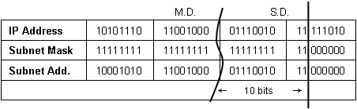
- The result is the Number of Subnet Bits, which can be determined by simply counting the number of bits between the M.D. and S.D., which in this case is 10 bits.
Step 4: Determine the bit ranges for subnets and hosts.
- Label the subnet counting range between the M.D. and the S.D. This range contains the bits that are being incremented to create the subnet numbers or addresses.
- Label the host counting range between the S.D. and the last bits at the end on the right. This range contains the bits that are being incremented to create the host numbers or addresses.

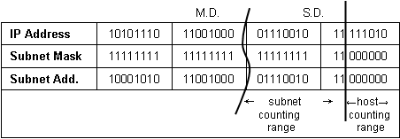

Step 5: Determine the range of host addresses available on this subnet and the broadcast address on this subnet.
- Copy down all of the network/subnet bits of the network address (that is, all bits before the S.D.).
- In the host portion (to the right of the S.D.), make the host bits all 0s except for the right-most bit (or least significant bit), which you make a 1. This gives us the first host IP address on this subnet, which is the first part of the result for Range of Host Addresses for This Subnet, which in the example is 172.25.114.193.
- Next, in the host portion (to the right of the S.D.), make the host bits all 1s except for the right-most bit (or least significant bit), which you make a 0. This gives us the last host IP address on this subnet, which is the last part of the result for Range of Host Addresses for This Subnet, which in the example is 172.25.114.254.
- In the host portion (to the right of the S.D.), make the host bits all 1s. This gives us the broadcast IP address on this subnet. This is the result for Broadcast Address of This Subnet, which in the example is 172.25.114.255.

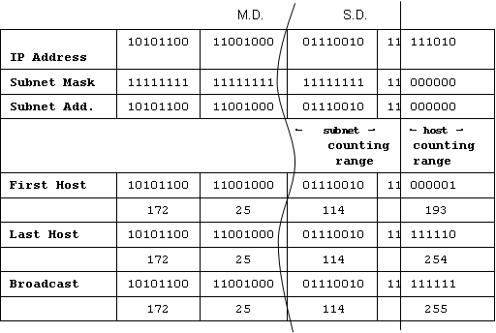

Let’s add some of this information to our table:

Host IP Address | 172.25.114.250
Major Network Mask | 255.255.0.0 (/16)
Major (Base) Network Address | 172.25.0.0
Major Network Broadcast Address | 172.25.255.255
Total Number of Host Bits  Number of Hosts | 16 bits or 2¹⁶ or 65,536 total hosts  65,536 – 2 = 65,534 usable hosts
Subnet Mask | 255.255.255.192 (/26)
Number of Subnet Bits
Number of Subnets
Number of Host Bits per Subnet
Number of Usable Hosts per Subnet
Subnet Address for this IP Address
IP Address of First Host on this Subnet
IP Address of Last Host on this Subnet
Broadcast Address for this Subnet

Step 6: Determine the number of subnets.
The number of subnets is determined by how many bits are in the subnet counting range (in this example, 10 bits).
Use the formula 2^{n}, where n is the number of bits in the subnet counting range.
- 2¹⁰ = 1024

Number of Subnet Bits  Number of Subnets  (all 0s used, all 1s not used) | 10 bits  2¹⁰ = 1024 subnets

Step 7: Determine the number usable hosts per subnet.
The number of hosts per subnet is determined by the number of host bits (in this example, 6 bits) minus 2 (1 for the subnet address and 1 for the broadcast address of the subnet).
2⁶ – 2 = 64 – 2 = 62 hosts per subnet
Number of Host Bits per Subnet  Number of Usable Hosts per Subnet | 6 bits  2⁶ – 2 = 64 – 2 = 62 hosts per subnet

Step 8: Final Answers
Host IP Address | 172.25.114.250
Subnet Mask | 255.255.255.192 (/26)
Number of Subnet Bits  Number of Subnets | 10 bits  2¹⁰ = 1024 subnets
Number of Host Bits per Subnet  Number of Usable Hosts per Subnet | 6 bits  2⁶ – 2 = 64 – 2 = 62 hosts per subnet
Subnet Address for this IP Address | 172.25.114.192
IP Address of First Host on this Subnet | 172.25.114.193
IP Address of Last Host on this Subnet | 172.25.114.254
Broadcast Address for this Subnet | 172.25.114.255
Task 2: Challenge.
For all problems:
Create a Subnetting Worksheet to show and record all work for each problem.
Problem 1
Host IP Address | 172.30.1.33
Subnet Mask | 255.255.255.0
Number of Subnet Bits
Number of Subnets

Number of Host Bits per Subnet
Number of Usable Hosts per Subnet
Subnet Address for this IP Address
IP Address of First Host on this Subnet
IP Address of Last Host on this Subnet
Broadcast Address for this Subnet

Problem 2
Host IP Address | 172.30.1.33
Subnet Mask | 255.255.255.252
Number of Subnet Bits
Number of Subnets

Number of Host Bits per Subnet
Number of Usable Hosts per Subnet
Subnet Address for this IP Address
IP Address of First Host on this Subnet
IP Address of Last Host on this Subnet
Broadcast Address for this Subnet

Problem 3
Host IP Address | 192.192.10.234
Subnet Mask | 255.255.255.0
Number of Subnet Bits
Number of Subnets

Number of Host Bits per Subnet
Number of Usable Hosts per Subnet
Subnet Address for this IP Address
IP Address of First Host on this Subnet
IP Address of Last Host on this Subnet
Broadcast Address for this Subnet

Problem 4
Host IP Address | 172.17.99.71
Subnet Mask | 255.255.0.0
Number of Subnet Bits
Number of Subnets

Number of Host Bits per Subnet
Number of Usable Hosts per Subnet
Subnet Address for this IP Address
IP Address of First Host on this Subnet
IP Address of Last Host on this Subnet
Broadcast Address for this Subnet

Problem 5
Host IP Address | 192.168.3.219
Subnet Mask | 255.255.255.0
Number of Subnet Bits
Number of Subnets

Number of Host Bits per Subnet
Number of Usable Hosts per Subnet
Subnet Address for this IP Address
IP Address of First Host on this Subnet
IP Address of Last Host on this Subnet
Broadcast Address for this Subnet

Problem 6
Host IP Address | 192.168.3.219
Subnet Mask | 255.255.255.252
Number of Subnet Bits
Number of Subnets

Number of Host Bits per Subnet
Number of Usable Hosts per Subnet
Subnet Address for this IP Address
IP Address of First Host on this Subnet
IP Address of Last Host on this Subnet
Broadcast Address for this Subnet
Task 3: Clean Up
Remove anything that was brought into the lab, and leave the room ready for the next class.

