Activity 3.4.1: Data Stream Capture

Learning Objectives
Upon completion of this activity, you will be able to:

- Capture or download an audio stream
- Record the characteristics of the file
- Examine data transfer rates associated with the file

Background
When an application creates a file, the data that comprises that file must be stored somewhere. The data can be stored on the end device where it was created, or it can be transferred for storage on another device.
In this activity, you will use a microphone and Microsoft Sound Recorder to capture an audio stream. Microsoft Sound Recorder is a Windows accessory that can be found in Windows XP at Start > Programs >Accessories > Entertainment > Sound Recorder. If a microphone and Microsoft Sound Recorder are not available, you can download an audio file to use in this activity from http://newsroom.cisco.com/dlls/podcasts/audio_feeds.html.

Scenario
This activity is to be performed on a computer that has a microphone and Microsoft Sound Recorder or Internet access so that an audio file can be downloaded.
Estimated completion time, depending on network speed, is 30 minutes.
Task 1: Create a Sound File
Step 1: Open the Windows Sound Recorder application.

The application can be found in Windows XP at Start > Programs >Accessories > Entertainment > Sound Recorder. The Sound Recorder interface is shown in Figure 1.

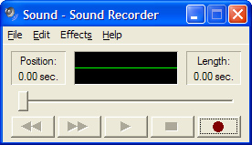
Figure 1. The Sound Recorder Interface
Step 2: Record an audio file.
- To begin recording, click the Record button on the Sound Recorder interface.
- Speak into the microphone, or create sounds that can be picked up by the microphone. As the audio is recorded, the waveform of the sound should appear on the Sound Recorder interface, as shown in Figure 2.
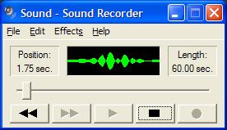
Figure 2. Recording in Progress
- Click the Stop button when you are finished.
Step 3: Check the audio file that was recorded.
- Press the Play button to listen to the recording. The recording that you have made should be played back, as shown in Figure 3.
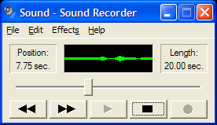
Figure 3. Playback
If you are unable to hear the recording, check the configuration of the microphone, speakers, and volume settings, and attempt to create the recording again.
If you are unable to create a recording, download an audio file from News@Cisco at the following URL: http://newsroom.cisco.com/dlls/podcasts/audio_feeds.html
- Save the audio file to the desktop and proceed to Task 2.
Step 4: Save the audio file.
- Save the audio file that you have created to the desktop. Name the file myaudio.wav.
- After the file is saved, close the Sound Recorder application.

Task 2: Observe the Properties of the Audio File
Step 1: View audio file properties.
Right-click the audio file that you saved to the desktop and click Properties from the popup menu.

What is the file size in kilobytes? _______________

What is the file size in bytes? _______________

What is the file size in bits? _______________

Step 2: Open the audio file in Windows Media Player.
- Right-click the audio file and select Open With > Windows Media Player.
- When the file is open, right-click at the top of the Media Player interface and select File > Properties from the popup menu.
What is the length of the audio file in seconds? _______________
Calculate the amount of data per second in the audio file and record the result. _______________
Task 3: Reflection
Data files do not have to remain on the end devices where they are created. For example, you may want to copy the audio file that you created to another computer or a portable audio device.
If the audio file that you saved to the desktop were to be transferred at a rate of 100 megabits per second (Mbps), how long would it take for the file transfer to be completed?

__________________________________________________________________________________

Even with an Ethernet connection operating at 100 Mbps, the data that makes up a file is not transferred at this speed. All Ethernet frames contain other information, such as source and destination addresses, that is necessary for the delivery of the frame.
If 5% of the available 100 Mbps bandwidth is used up by the Ethernet overhead, and 95% of the bandwidth is left for the data payload, how long would it take for the file transfer to be completed?

___________________________________________________________________________________

Task 4: Clean Up
You may be required to remove the audio file that you have saved from the computer. If so, delete the file from the desktop.
Unless instructed otherwise, turn off the computer.

