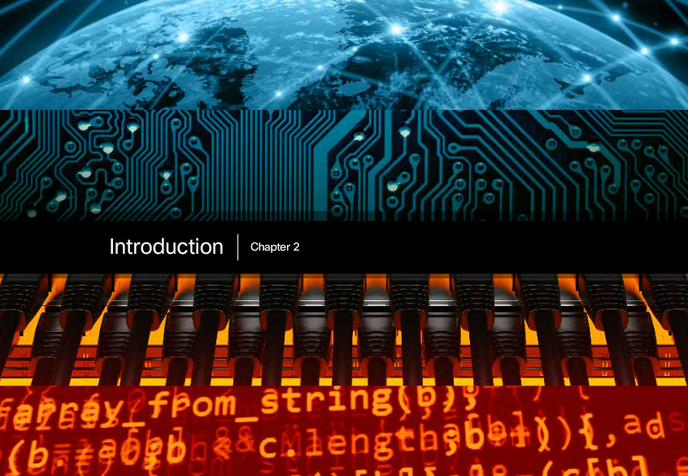

Chapter 2: Configure a Network Operating System
Every computer requires an operating system to function, including computer-based network devices such as switches, routers, access points, and firewalls. These network devices use an operating system called a network operating system.
A network operating system enables device hardware to function and provides an interface for users to interact. In the CCNA course of study, students learn to configure both devices that connect to the network (end devices such as PCs) and devices that connect networks together (intermediary devices like routers and switches). Learning to configure the Cisco Internetwork Operating System (Cisco IOS) on Cisco routers and switches is a large part of the Cisco CCNA program of study.
The Cisco Internetwork Operating System (IOS) is a generic term for the collection of network operating systems used by Cisco networking devices. Cisco IOS is used for most Cisco devices, regardless of the type or size.

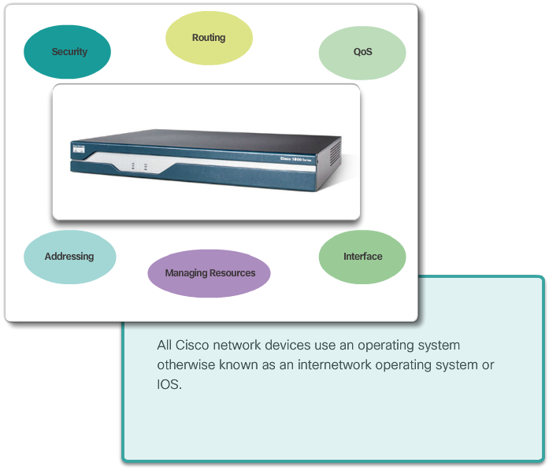

Class Activity - It Is Just an Operating System
In this activity, imagine that you are employed as an engineer for a car manufacturing company. The company is currently working on a new car model. This model will have selected functions that can be controlled by the driver giving specific voice commands.
Design a set of commands used by this voice-activated control system, and identify how they are going to be executed. The functions of the car that can be controlled by voice commands are:
- Lights
- Wipers
- Radio
- Telephone set
- Air conditioning
- Ignition
Class Activity - It Is Just an Operating System Instructions

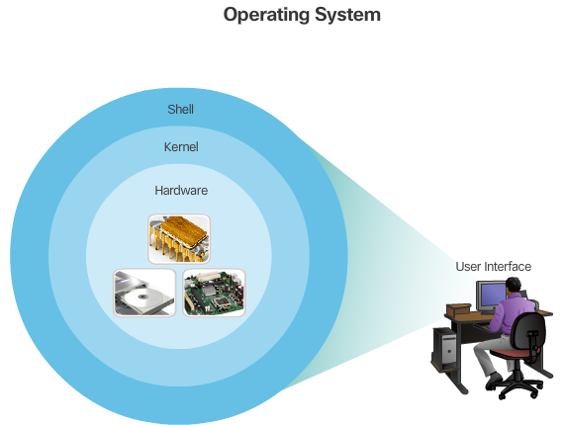

Operating Systems
All end devices and network devices require an operating system (OS). As shown in Figure 1, the portion of the OS that interacts directly with computer hardware is known as the kernel. The portion that interfaces with applications and the user is known as the shell. The user can interact with the shell using a command-line interface (CLI) or a graphical user interface (GUI).
When using a CLI as shown in Figure 2, the user interacts directly with the system in a text-based environment by entering commands on the keyboard at a command prompt. The system executes the command, often providing textual output. The CLI requires very little overhead to operate. However, it does require that the user have knowledge of the underlying structure that controls the system.
A GUI interface such as Windows, OS X, Apple iOS, or Android allows the user to interact with the system using an environment of graphical icons, menus, and windows. The GUI example in Figure 3 is more user-friendly and requires less knowledge of the underlying command structure that controls the system. For this reason, many individuals rely on GUI environments.
However, GUIs may not always be able to provide all of the features available at the CLI. GUIs can also fail, crash, or simply not operate as specified. For these reasons, network devices are typically accessed through a CLI. The CLI is less resource intensive and very stable when compared to a GUI.
The network operating system used on Cisco devices is called the Cisco Internetwork Operating System (IOS). Cisco IOS is used for most Cisco devices regardless of the type or size of the device.
Note: The operating system on home routers is usually called firmware. The most common method for configuring a home router is by using a web browser-based GUI.

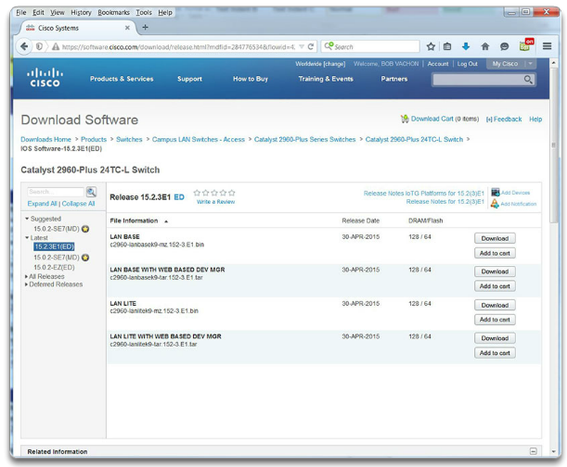

Purpose of OS
Network operating systems are similar to a PC operating system. Through a GUI, a PC operating system enables a user to:
- Use a mouse to make selections and run programs
- Enter text and text-based commands
- View output on a monitor
A CLI-based network operating system like the Cisco IOS on a switch or router enables a network technician to:
- Use a keyboard to run CLI-based network programs
- Use a keyboard to enter text and text-based commands
- View output on a monitor
Cisco networking devices run particular versions of the Cisco IOS. The IOS version is dependent on the type of device being used and the required features. While all devices come with a default IOS and feature set, it is possible to upgrade the IOS version or feature set to obtain additional capabilities.
In this course, you will focus primarily on Cisco IOS Release 15.x. The figure displays a list of IOS software releases for a Cisco Catalyst 2960 Switch. The chapter appendix includes a video that introduces you to Cisco Connection Online. Here you can discover a wealth of information about Cisco products and services.

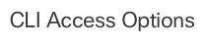
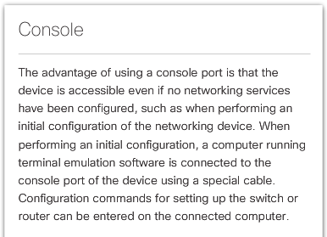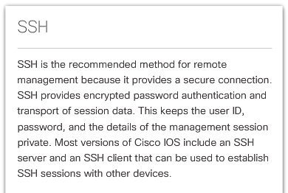
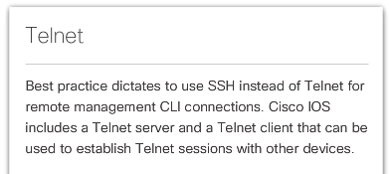

Access Methods
A Cisco IOS switch can be implemented with no configuration and still switch data between connected devices. By connecting two PCs to a switch, those PCs will instantly have connectivity with one another.
Even though a Cisco switch will function immediately, configuring initial settings are a recommended best practice. There are several ways to access the CLI environment and configure the device. The most common methods are:
- Console – This is a physical management port that provides out-of-band access to a Cisco device. Out-of-band access refers to access via a dedicated management channel that is used for device maintenance purposes only.
- Secure Shell (SSH) – SSH is a method for remotely establishing a secure CLI connection through a virtual interface, over a network. Unlike a console connection, SSH connections require active networking services on the device including an active interface configured with an address.
- Telnet - Telnet is an insecure method of remotely establishing a CLI session through a virtual interface, over a network. Unlike SSH, Telnet does not provide a securely encrypted connection. User authentication, passwords, and commands are sent over the network in plaintext.
Click the options in the figure to view additional information.
Note: Some devices, such as routers, may also support a legacy auxiliary port that was used to establish a CLI session remotely using a modem. Similar to a console connection, the AUX port is out-of-band and does not require networking services to be configured or available.

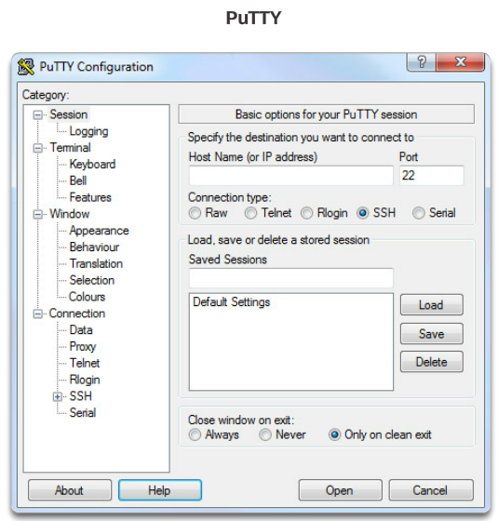

Terminal Emulation Programs
There are a number of excellent terminal emulation programs available for connecting to a networking device either by a serial connection over a console port or by a SSH/Telnet connection. Some of these include:
- PuTTY (Figure 1)
- Tera Term (Figure 2)
- SecureCRT (Figure 3)
- OS X Terminal
These programs allow you to enhance your productivity by adjusting window sizes, changing font sizes, and changing color schemes.

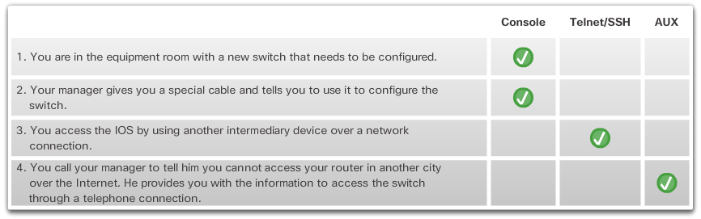

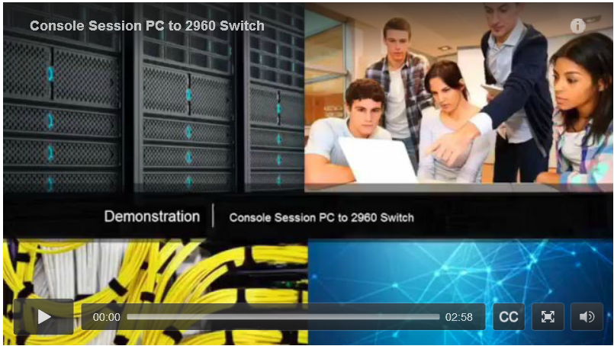

Cisco IOS Modes of Operation
To initially configure a Cisco device, a console connection must be established. Once consoled in, the network technician will have to navigate through various command modes of the IOS CLI. The Cisco IOS modes use a hierarchical structure and are quite similar for both switches and routers.
Click Play in the figure to view a video demonstration of how to establish a console connection with a switch.
Click here to read the transcript of this video.

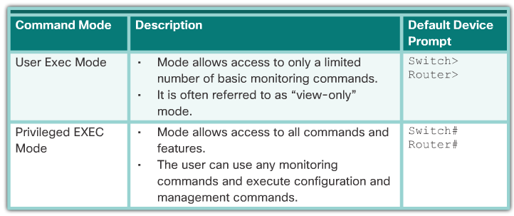

Primary Command Modes
As a security feature, the Cisco IOS software separates management access into the following two command modes:
- User EXEC Mode - This mode has limited capabilities but is useful for basic operations. It allows only a limited number of basic monitoring commands but does not allow the execution of any commands that might change the configuration of the device. The user EXEC mode is identified by the CLI prompt that ends with the > symbol.
- Privileged EXEC Mode - To execute configuration commands, a network administrator must access privileged EXEC mode. Higher configuration modes, like global configuration mode, can only be reached from privileged EXEC mode. The privileged EXEC mode can be identified by the prompt ending with the # symbol.
The table in the figure summarizes the two modes and displays the default CLI prompts of a Cisco switch and router.

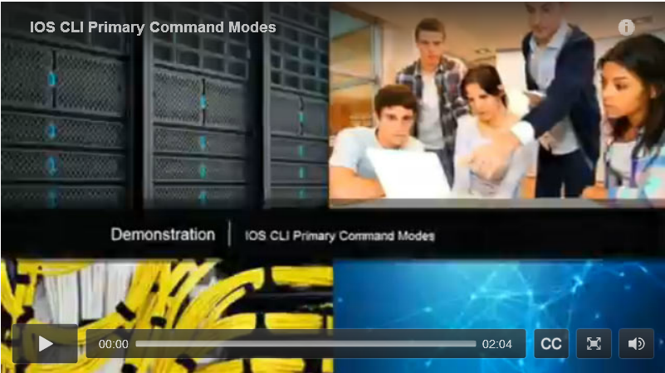

Configuration Command Modes
To configure the device, the user must enter Global Configuration Mode, which is commonly called global config mode.
From global config mode, CLI configuration changes are made that affect the operation of the device as a whole. Global configuration mode is identified by a prompt that ends with (config)# after the device name, such as Switch(config)#.
Global configuration mode is accessed before other specific configuration modes. From global config mode, the user can enter different sub-configuration modes. Each of these modes allows the configuration of a particular part or function of the IOS device. Two common sub-configuration modes include:
- Line Configuration Mode - Used to configure console, SSH, Telnet, or AUX access.
- Interface Configuration Mode - Used to configure a switch port or router network interface.
When using the CLI, the mode is identified by the command-line prompt that is unique to that mode. By default, every prompt begins with the device name. Following the name, the remainder of the prompt indicates the mode. For example, the default prompt for line configuration mode is Switch(config-line)# and the default prompt for interface configuration mode is Switch(config-if)#.
Click Play in the figure to view a video demonstration of navigating between IOS modes.
Click here to read the transcript of this video.

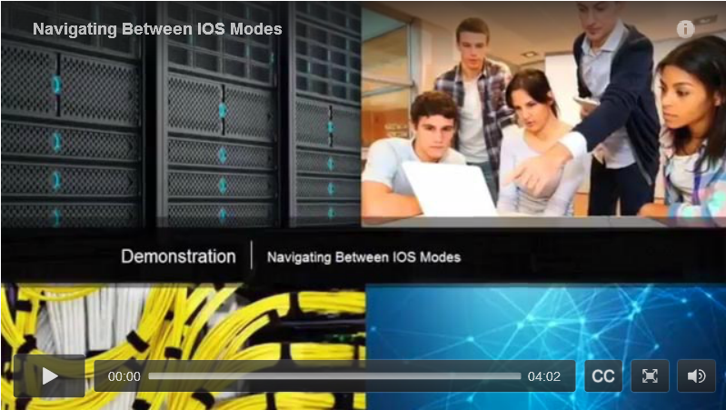

Navigate Between IOS Modes
Various commands are used to move in and out of command prompts. To move from user EXEC mode to privileged EXEC mode, use the enable command. Use the disable privileged EXEC mode command to return to user EXEC mode.
Note: Privileged EXEC mode is sometimes called enable mode.
To move in and out of global configuration mode, use the configure terminal privileged EXEC mode command. To return to the privileged EXEC mode, enter the exit global config mode command.
There are many different sub-configuration modes. For example, to enter line sub-configuration mode, you use the line command followed by the management line type and number you wish to access. To exit a sub-configuration mode and return to global configuration mode, use the exit command. Notice the changes in the command prompt.
Switch(config)# line console 0
Switch(config-line)#
To move from any sub-configuration mode of the global configuration mode to the mode one step above it in the hierarchy of modes, enter the exit command.
Switch(config-line)# exit
Switch(config)#
To move from any sub-configuration mode to the privileged EXEC mode, enter the end command or enter the key combination Ctrl+Z.
Switch(config-line)# end
Switch#
You can also move directly from one sub-configuration mode to another. Notice how after the network device name, the command prompt changes from (config-line)# to (config-if)#.
Switch(config-line)# interface FastEthernet 0/1
Switch(config-if)#
Click Play in the figure to view a video demonstration of how to move between various IOS CLI modes.
Click here to read the transcript of this video.

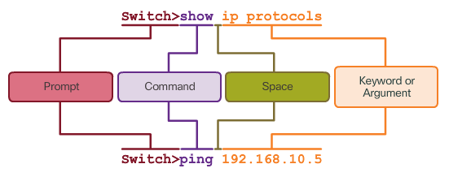

Basic IOS Command Structure
A Cisco IOS device supports many commands. Each IOS command has a specific format or syntax and can only be executed in the appropriate mode. The general syntax for a command is the command followed by any appropriate keywords and arguments.
- Keyword - a specific parameter defined in the operating system (in the figure, ip protocols)
- Argument - not predefined; a value or variable defined by the user (in the figure, 192.168.10.5)
After entering each complete command, including any keywords and arguments, press the Enter key to submit the command to the command interpreter.

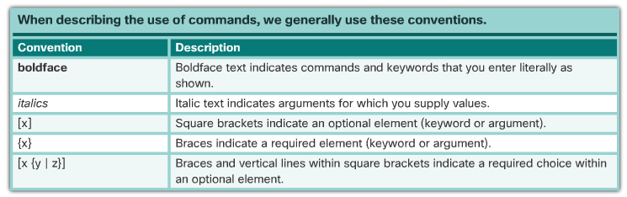

IOS Command Syntax
A command might require one or more arguments. To determine the keywords and arguments required for a command, refer to the command syntax. The syntax provides the pattern or format that must be used when entering a command.
As identified in the table in the figure, boldface text indicates commands and keywords that are entered as shown. Italic text indicates an argument for which the user provides the value.
For instance, the syntax for using the description command is description string. The argument is a string value provided by the user. The description command is typically used to identify the purpose of an interface. For example, entering the command, description Connects to the main headquarter office switch, describes where the other device is at the end of the connection.
The following examples demonstrate conventions used to document and use IOS commands.
- ping ip-address - The command is ping and the user-defined argument is the ip-address of the destination device. For example, ping 10.10.10.5.
- traceroute ip-address - The command is traceroute and the user-defined argument is the ip-address of the destination device. For example, traceroute 192.168.254.254.
The Cisco IOS Command Reference is the ultimate source of information for a particular IOS command. Refer to the Chapter Appendix to learn more about the Cisco IOS Command Reference.

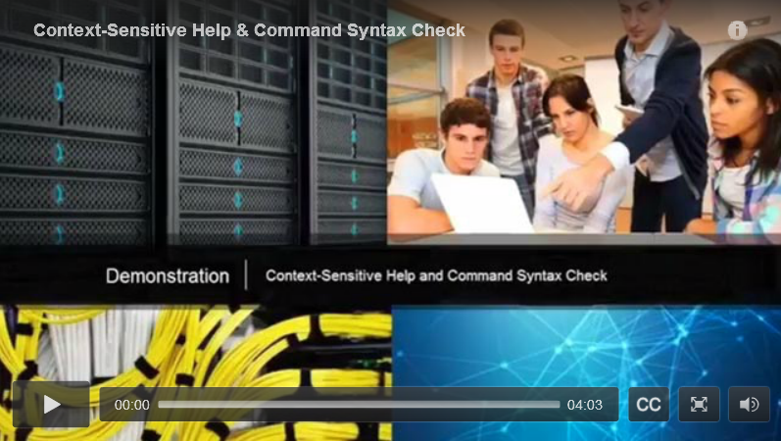

IOS Help Features
The IOS has two forms of help available:
- Context-Sensitive Help
- Command Syntax Check
Context-sensitive help enables you to quickly find which commands are available in each command mode, which commands start with specific characters or group of characters, and which arguments and keywords are available to particular commands. To access context-sensitive help, simply enter a question mark, ?, at the CLI.
Command syntax check verifies that a valid command was entered by the user. When a command is entered, the command line interpreter evaluates the command from left to right. If the interpreter understands the command, the requested action is executed, and the CLI returns to the appropriate prompt. However, if the interpreter cannot understand the command being entered, it will provide feedback describing what is wrong with the command.
Click Play in the figure to view a video demonstration of context-sensitive help and command syntax check.
Click here to read the transcript of this video.

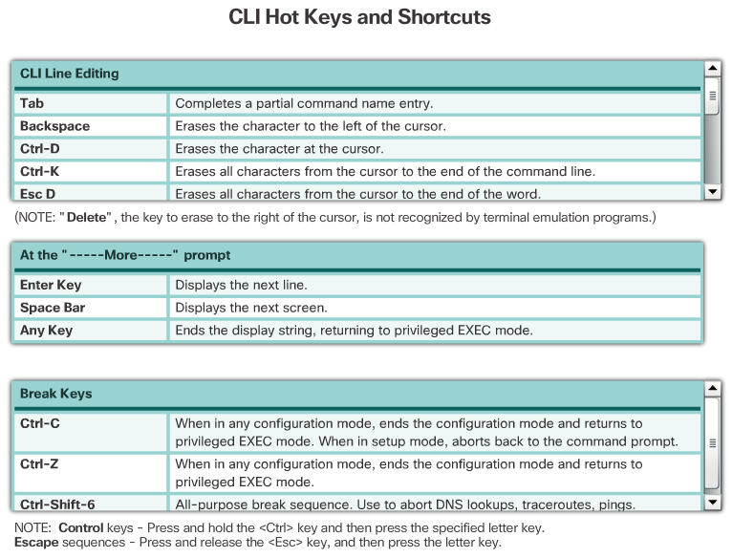

Hotkeys and Shortcuts
The IOS CLI provides hot keys and shortcuts that make configuring, monitoring, and troubleshooting easier, as shown in the figure.
Commands and keywords can be abbreviated to the minimum number of characters that identify a unique selection. For example, the configure command can be abbreviated to conf because configure is the only command that begins with conf. An abbreviation of con will not work because more than one command begins with con. Keywords can also be abbreviated.

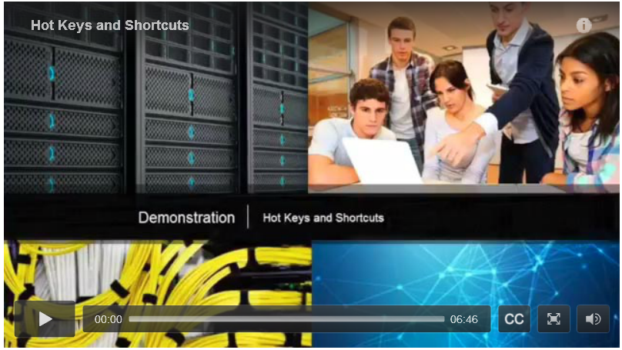

Video Demonstration – Hotkeys and Shortcuts
Click Play in the figure to view a video demonstration of the various hotkeys and shortcuts.
Refer to the Chapter Appendix to learn more about Cisco IOS commands used to verify and troubleshoot network operations.
Click here to read the transcript of this video.

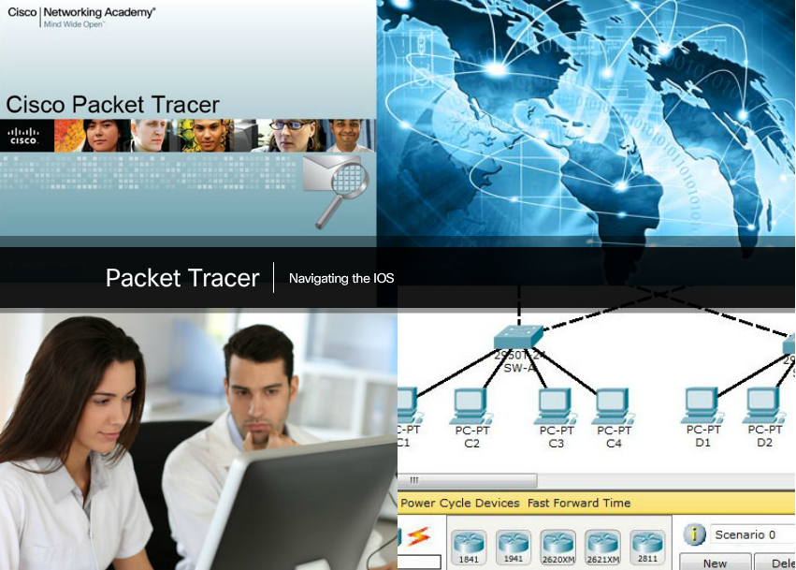

Packet Tracer - Navigating the IOS
In this activity, you will practice skills necessary for navigating the Cisco IOS, including different user access modes, various configuration modes, and common commands used on a regular basis. You also practice accessing the context-sensitive help by configuring the clock command.
Packet Tracer - Navigating the IOS Instructions
Packet Tracer - Navigating the IOS - PKA

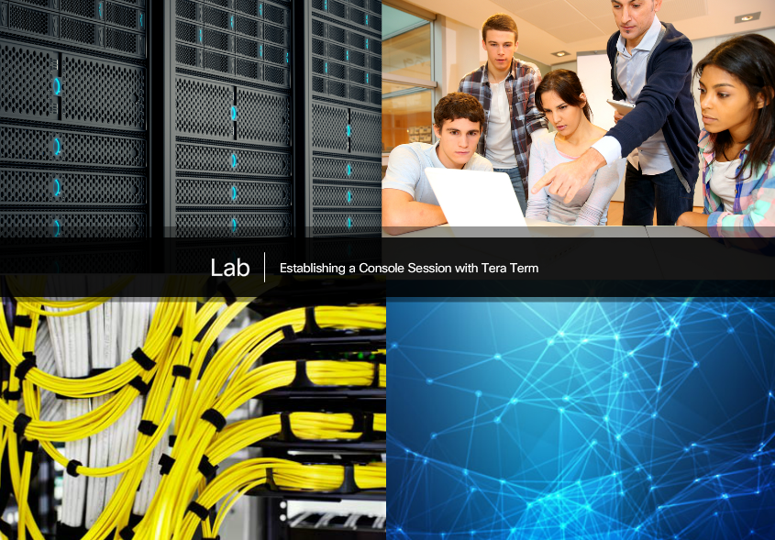

Lab - Establishing a Console Session with Tera Term
In this lab, you will complete the following objectives:
- Part 1: Access a Cisco Switch through the Serial Console Port
- Part 2: Display and Configure Basic Device Settings
- Part 3: (Optional) Access a Cisco Router Using a Mini-USB Console Cable
Lab - Establishing a Console Session with Tera Term

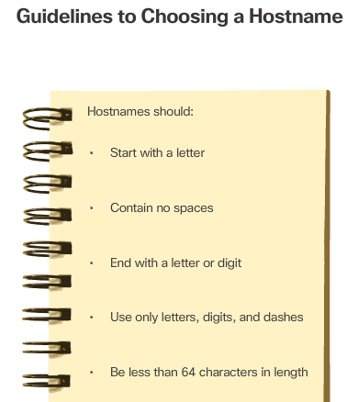

Device Names
When configuring a networking device, one of the first steps is configuring a unique device name or hostname. Hostnames that appear in CLI prompts can be used in various authentication processes between devices, and should be used on topology diagrams.
If the device name is not explicitly configured, a factory assigned default name is used by the Cisco IOS. The default name for a Cisco IOS switch is "Switch." If all network devices were left with their default names, it would be difficult to identify a specific device. For instance, when accessing a remote device using SSH, it is important to have confirmation that you are connected to the proper device.
By choosing names wisely, it is easier to remember, document, and identify network devices. Guidelines for hostname configuration are listed in Figure 1.
The hostnames used in the device IOS preserve capitalization and lowercase characters. Therefore, it allows you to capitalize a name as you ordinarily would. This contrasts with most Internet naming schemes, where uppercase and lowercase characters are treated identically.
For example, in Figure 2, three switches, spanning three different floors, are interconnected together in a network. The naming convention used took into consideration the location and the purpose of each device. Network documentation should explain how these names were chosen so additional devices can be named accordingly.

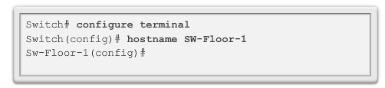

Configure Hostnames
Once the naming convention has been identified, the next step is to apply the names to the devices using the CLI.
As shown in Figure 1, from the privileged EXEC mode, access the global configuration mode by entering the configure terminal command. Notice the change in the command prompt.
From global configuration mode, enter the command hostname followed by the name of the switch and press Enter. Notice the change in the command prompt name.
Note: To remove the configured hostname and return the switch to the default prompt, use the no hostname global config command.
Always make sure the documentation is updated each time a device is added or modified. Identify devices in the documentation by their location, purpose, and address.
Use the Syntax Checker in Figure 2 to practice entering a hostname on a switch.

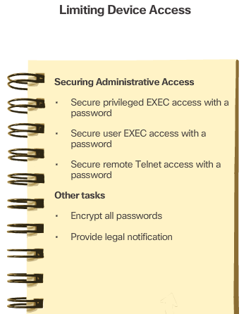

Secure Device Access
The use of weak or easily guessed passwords continues to be a security issue in many facets of the business world. Network devices, including home wireless routers, should always have passwords configured to limit administrative access.
Cisco IOS can be configured to use hierarchical mode passwords to allow different access privileges to a network device.
All networking devices should limit access as listed in Figure 1.
Use strong passwords that are not easily guessed. Consider the key points listed in Figure 2.
Note: Most of the labs in this course use simple passwords such as cisco or class. These passwords are considered weak and easily guessable and should be avoided in production environments. We only use these passwords for convenience in a classroom setting or to illustrate configuration examples.

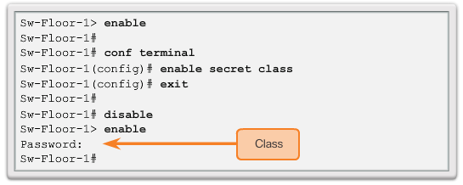

Configure Passwords
The most important password to configure is access to the privileged EXEC mode, as shown in Figure 1. To secure privileged EXEC access, use the enable secret password global config command.
To secure the user EXEC access, the console port must be configured, as shown in Figure 2. Enter line console configuration mode using the line console 0 global configuration command. The zero is used to represent the first (and in most cases the only) console interface. Next, specify the user EXEC mode password using the password password command. Finally, enable user EXEC access using the login command. Console access will now require a password before gaining access to the user EXEC mode.
VTY lines enable remote access to the device. To secure VTY lines used for SSH and Telnet, enter line VTY mode using the line vty 0 15 global config command, as shown in Figure 3. Many Cisco switches support up to 16 VTY lines that are numbered 0 to 15. Next, specify the VTY password using the password password command. Lastly, enable VTY access using the login command.

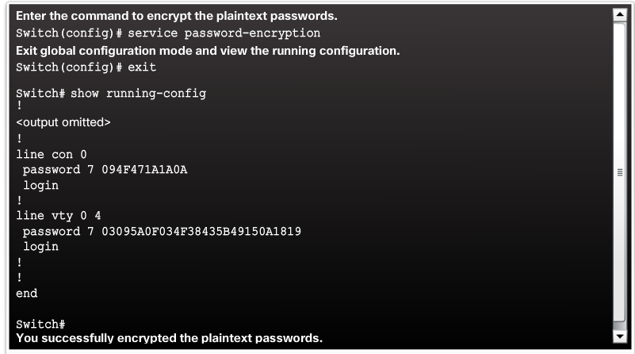

Encrypt Passwords
The startup-config and running-config files display most passwords in plaintext. This is a security threat since anyone can see the passwords used if they have access to these files.
To encrypt passwords, use the service password-encryption global config command. The command applies weak encryption to all unencrypted passwords. This encryption applies only to passwords in the configuration file, not to passwords as they are sent over the network. The purpose of this command is to keep unauthorized individuals from viewing passwords in the configuration file.
Use the Syntax Checker in the figure to practice encrypting passwords.

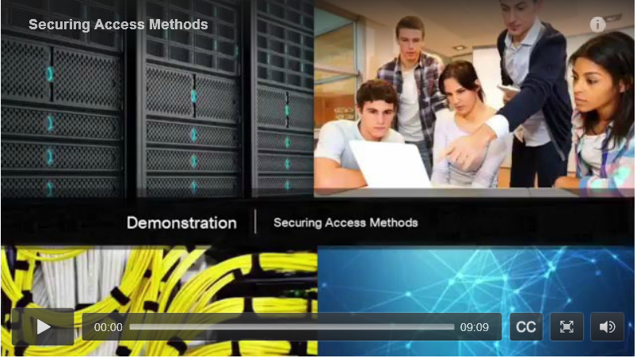

Banner Messages
Although requiring passwords is one way to keep unauthorized personnel out of a network, it is vital to provide a method for declaring that only authorized personnel should attempt to gain entry into the device. To do this, add a banner to the device output. Banners can be an important part of the legal process in the event that someone is prosecuted for breaking into a device. Some legal systems do not allow prosecution, or even the monitoring of users, unless a notification is visible.
To create a banner message of the day on a network device, use the banner motd # the message of the day # global config command. The “#” in the command syntax is called the delimiting character. It is entered before and after the message. The delimiting character can be any character as long as it does not occur in the message. For this reason, symbols such as the "#" are often used. After the command is executed, the banner will be displayed on all subsequent attempts to access the device until the banner is removed.
Because banners can be seen by anyone who attempts to log in, the message must be worded very carefully. The exact content or wording of a banner depends on the local laws and corporate policies. The banner should state that only authorized personnel are allowed to access the device. Any wording that implies a login is "welcome" or "invited" is inappropriate. Further, the banner can include scheduled system shutdowns and other information that affects all network users.
Click Play in the figure to view a video demonstration of how to secure administrative access to a switch.
Click here to read the transcript of this video.

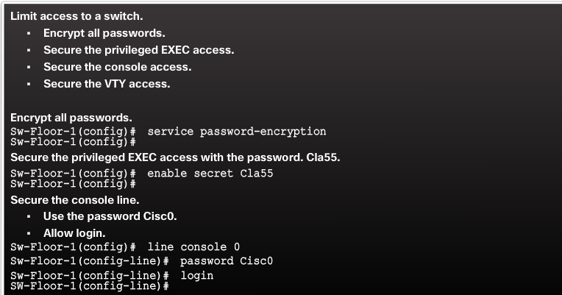
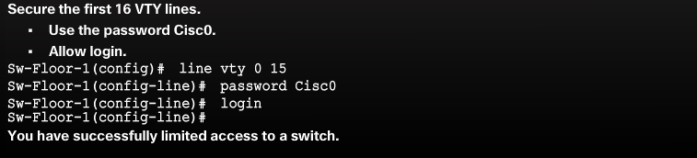

Syntax Checker - Limiting Access to a Switch
Use the Syntax Checker in the figure to practice the commands that limit access to a switch.

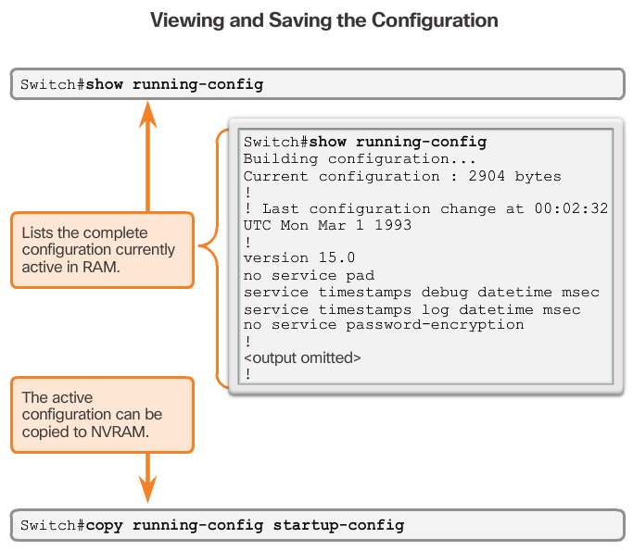

Save the Running Configuration File
There are two system files that store the device configuration:
- startup-config - The file stored in Non-volatile Random Access Memory (NVRAM) that contains all of the commands that will be used by the device upon startup or reboot. NVRAM does not lose its contents when the device is powered off.
- running-config - The file stored in Random Access Memory (RAM) that reflects the current configuration. Modifying a running configuration affects the operation of a Cisco device immediately. RAM is volatile memory. It loses all of its content when the device is powered off or restarted.
As shown in the figure, use the show running-config privileged EXEC mode command to view the running configuration file. To view the startup configuration file, use the show startup-config privileged EXEC command.
If power to the device is lost or if the device is restarted, all configuration changes will be lost unless they have been saved. To save changes made to the running configuration to the startup configuration file use the copy running-config startup-config privileged EXEC mode command.

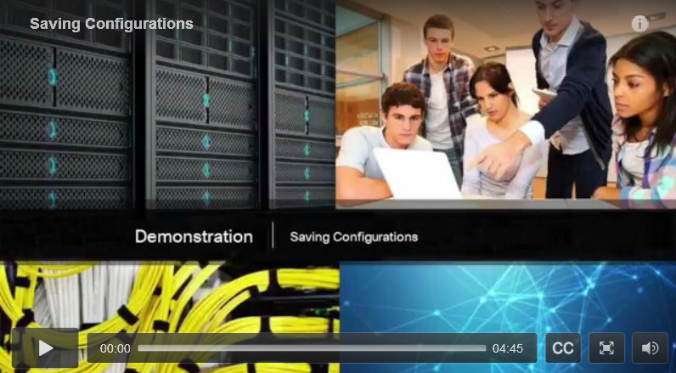

Alter the Running Configuration
If changes made to the running configuration do not have the desired effect and the running-config file has not yet been saved, you can restore the device to its previous configuration by removing the changed commands individually or reload the device using the reload privileged EXEC mode command to restore the startup-config.
The downside to using the reload command to remove an unsaved running configuration is the brief amount of time the device will be offline, causing network downtime.
When initiating a reload, the IOS will detect that the running config has changes that were not saved to the startup configuration. A prompt will appear to ask whether to save the changes. To discard the changes, enter n or no.
Alternatively, if undesired changes were saved to the startup configuration, it may be necessary to clear all the configurations. This requires erasing the startup configuration and restarting the device. The startup configuration is removed by using the erase startup-config privileged EXEC mode command. After the command is issued, the switch will prompt you for confirmation. Press Enter to accept.
After removing the startup configuration from NVRAM, reload the device to remove the current running configuration file from RAM. On reload, a switch will load the default startup configuration that originally shipped with the device.
Click Play in the figure to view a video demonstration on how to save switch configuration files.
Click here to read the transcript of this video.

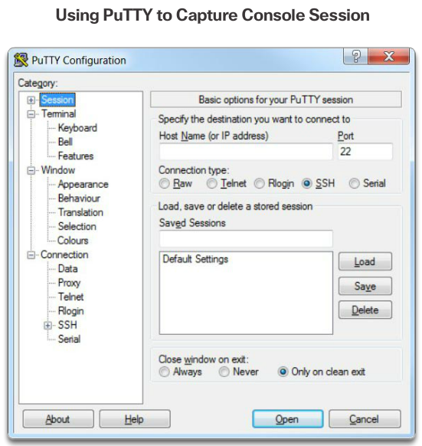

Capture Configuration to a Text File
Configuration files can also be saved and archived to a text document. This sequence of steps ensures that a working copy of the configuration file is available for editing or reuse later.
For example, assume that a switch has been configured, and the running configuration has been saved on the device.
- Open a terminal emulation software such as PuTTY or Tera Term (Figure 1) connected to a switch.
- Enable logging in the terminal software, such as PuTTY or Tera Term, and assign a name and file location to save the log file. Figure 2 displays that All session output will be captured to the file specified (i.e., MySwitchLogs).
- Execute the show running-config or show startup-config command at the privileged EXEC prompt. Text displayed in the terminal window will be placed into the chosen file.
- Disable logging in the terminal software. Figure 3 shows how to disable logging by choosing the None session logging option.
The text file created can be used as a record of how the device is currently implemented. The file could require editing before being used to restore a saved configuration to a device.
To restore a configuration file to a device:
- Enter global configuration mode on the device.
- Copy and paste the text file into the terminal window connected to the switch.
The text in the file will be applied as commands in the CLI and become the running configuration on the device. This is a convenient method of manually configuring a device.

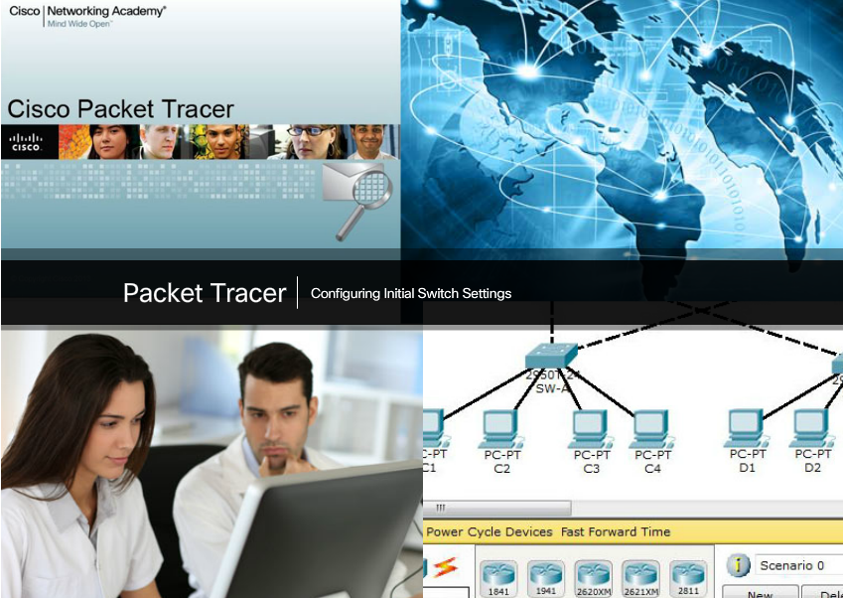

Packet Tracer - Configuring Initial Switch Settings
In this activity, you will perform basic switch configurations. You will secure access to the command-line interface (CLI) and console ports using encrypted and plain text passwords. You will learn how to configure messages for users logging into the switch. These banners are also used to warn unauthorized users that access is prohibited.
Packet Tracer - Configuring Initial Switch Settings Instructions
Packet Tracer - Configuring Initial Switch Settings - PKA

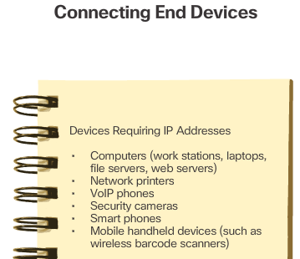

IP Addresses
The use of IP addresses is the primary means of enabling devices to locate one another and establish end-to-end communication on the Internet. Each end device on a network must be configured with an IP address. Examples of end devices are listed in Figure 1.
The structure of an IPv4 address is called dotted decimal notation and is represented by four decimal numbers between 0 and 255. IPv4 addresses are assigned to individual devices connected to a network.
With the IPv4 address, a subnet mask is also necessary. A subnet mask is a special type of IPv4 address. Coupled with the IPv4 address, the subnet mask determines which particular subnet the device is a member.
The example in Figure 2 displays the IPv4 address (192.168.1.10), subnet mask (255.255.255.0), and default gateway (192.168.1.1) assigned to a host. The default gateway address is the IP address of the router that the host will use to access remote networks, including the Internet.
IP addresses can be assigned to both physical ports and virtual interfaces on devices. A virtual interface means that there is no physical hardware on the device associated with it.

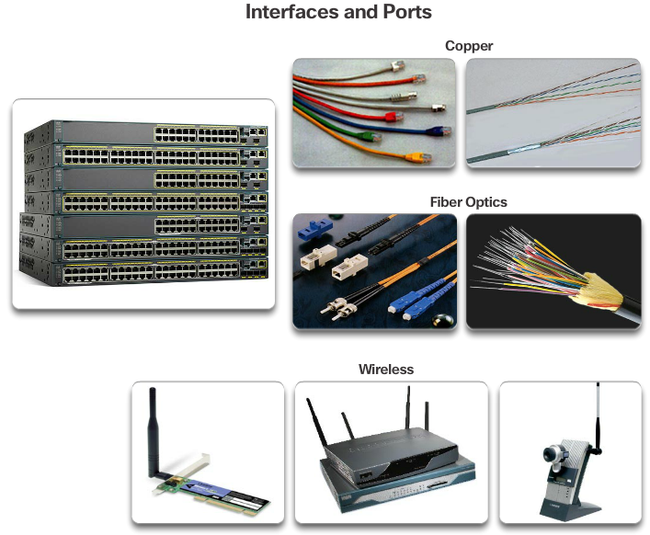

Interfaces and Ports
Network communications depend on end user device interfaces, networking device interfaces, and the cables that connect them. Each physical interface has specifications, or standards, that define it. A cable connecting to the interface must be designed to match the physical standards of the interface. Types of network media include twisted-pair copper cables, fiber-optic cables, coaxial cables, or wireless as shown in the figure.
Different types of network media have different features and benefits. Not all network media has the same characteristics and is appropriate for the same purpose. Some of the differences between various types of media include:
- Distance the media can successfully carry a signal
- Environment in which the media is to be installed
- Amount of data and the speed at which it must be transmitted
- Cost of the media and installation
Not only does each link on the Internet require a specific network media type, but each link also requires a particular network technology. For example, Ethernet is the most common local area network (LAN) technology used today. Ethernet ports are found on end-user devices, switch devices, and other networking devices that can physically connect to the network using a cable.
Cisco IOS Layer 2 switches have physical ports for devices to connect. These ports do not support Layer 3 IP addresses. Therefore, switches have one or more switch virtual interfaces (SVIs). These are virtual interfaces because there is no physical hardware on the device associated with it. An SVI is created in software.
The virtual interface provides a means to remotely manage a switch over a network using IPv4. Each switch comes with one SVI appearing in the default configuration "out-of-the-box." The default SVI is interface VLAN1.
Note: A Layer 2 switch does not need an IP address. The IP address assigned to the SVI is used to remotely access the switch. An IP address is not necessary for the switch to perform its operations.

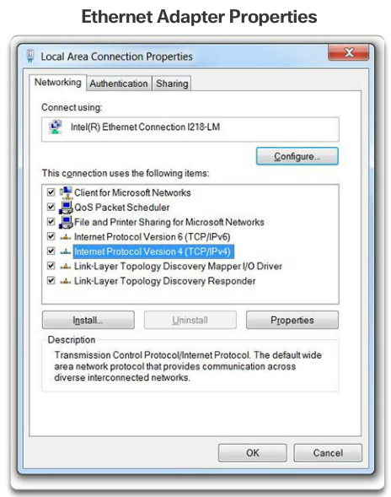

Manual IP Address Configuration for End Devices
In order for an end device to communicate over the network, it must be configured with a unique IP address and subnet mask. IP address information can be entered into end devices manually, or automatically using Dynamic Host Configuration Protocol (DHCP).
To manually configure an IP address on a Windows host, open the Control Panel > Network Sharing Center > Change adapter settings and choose the adapter. Next right-click and select Properties to display the Local Area Connection Properties shown in Figure 1.
Highlight Internet Protocol Version 4 (TCP/IPv4) and click Properties to open the Internet Protocol Version 4 (TCP/IPv4) Properties window shown in Figure 2. Configure the IPv4 address and subnet mask information, and default gateway.
Note: The DNS server addresses are the IP addresses of the Domain Name System (DNS) servers, which are used to translate IP addresses to domain names, such as www.cisco.com.

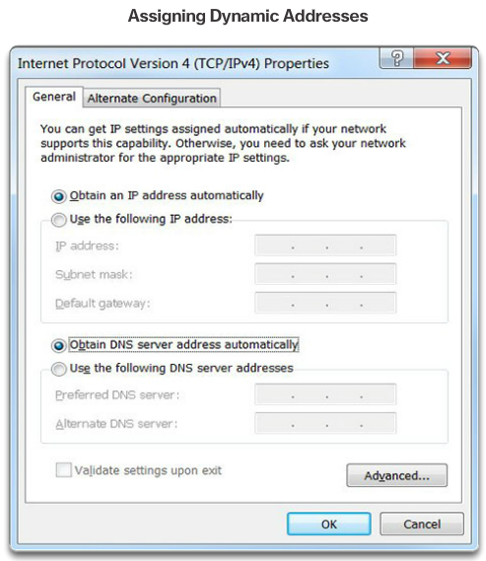

Automatic IP Address Configuration for End Devices
PCs typically default to using DHCP for automatic IP address configuration. DHCP is a technology that is used in almost every network. The best way to understand why DHCP is so popular is by considering all the extra work that would have to take place without it.
In a network, DHCP enables automatic IPv4 address configuration for every end device that has DHCP enabled. Imagine the amount of time it would consume if every time you connected to the network, you had to manually enter the IP address, the subnet mask, the default gateway, and the DNS server. Multiply that by every user and every device in an organization and you see the problem. Manual configuration also increases the chance of misconfiguration by duplicating another device’s IP address.
As shown in Figure 1, to configure DHCP on a Windows PC, you only need to select “Obtain an IP address automatically" and “Obtain DNS server address automatically". Your PC will search out a DHCP server and be assigned the address settings necessary to communicate on the network.
It is possible to display the IP configuration settings on a Windows PC by using the ipconfig command at the command prompt. The output will show the IP address, subnet mask, and gateway information received from the DHCP server.
Use the Syntax Checker in Figure 2 to practice displaying the IP address on a Windows PC.

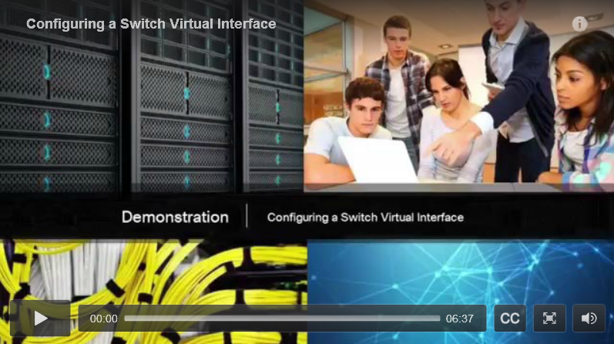

Switch Virtual Interface Configuration
To access the switch remotely, an IP address and a subnet mask must be configured on the SVI. To configure an SVI on a switch, use the interface vlan 1 global configuration command. Vlan 1 is not an actual physical interface but a virtual one. Next assign an IPv4 address using the ip address ip-address subnet-mask interface configuration command. Finally, enable the virtual interface using the no shutdown interface configuration command.
After these commands are configured, the switch has all the IPv4 elements ready for communication over the network.
Click Play in the figure to view a video demonstration of how to configure a switch virtual interface.
Click here to read the transcript of this video.

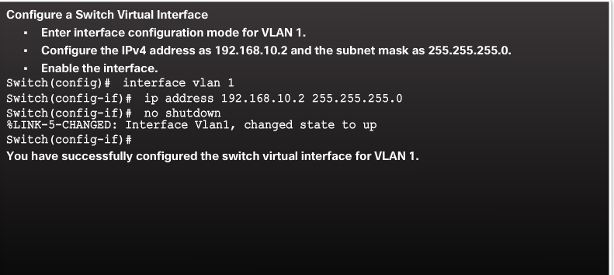

Syntax Checker - Configuring a Switch Virtual Interface
Use the Syntax Checker in the figure to practice configuring a switch virtual interface.

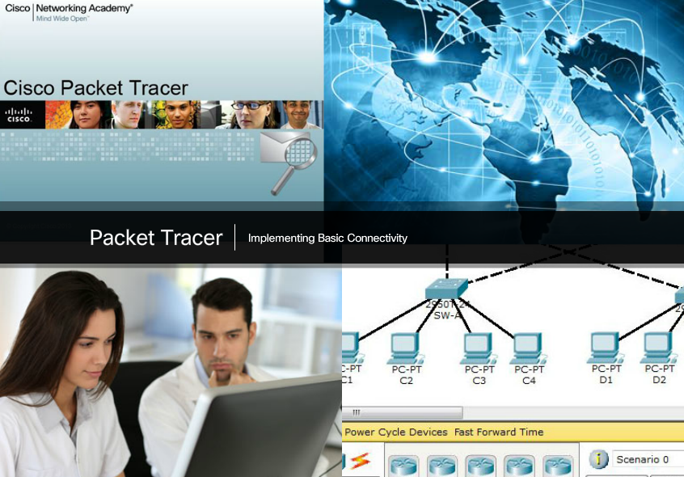

Packet Tracer - Implementing Basic Connectivity
In this activity, you will first perform basic switch configurations. Then you will implement basic connectivity by configuring IP addressing on switches and PCs. When the IP addressing configuration is complete, you will use various show commands to verify configurations and use the ping command to verify basic connectivity between devices.
Packet Tracer - Implementing Basic Connectivity Instructions
Packet Tracer - Implementing Basic Connectivity – PKA

Interface Addressing Verification
In the same way that you use commands and utilities like ipconfig to verify a PC host’s network configuration, you also use commands to verify the interfaces and address settings of intermediary devices like switches and routers.
Click Play in the figure to view a video demonstration of the show ip interface brief command. This command is useful for verifying the condition of the switch interfaces.
Click here to read the transcript of this video.

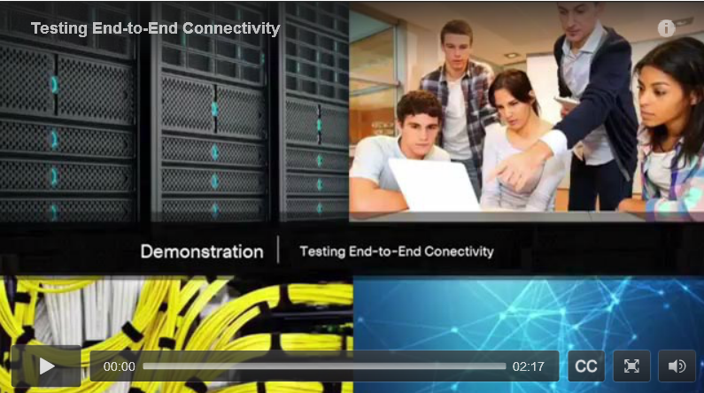

End-to-End Connectivity Test
The ping command can be used to test connectivity to another device on the network or a website on the Internet.
Click Play in the figure to view a video demonstration using the ping command to test connectivity to a switch and to another PC.
Click here to read the transcript of this video.

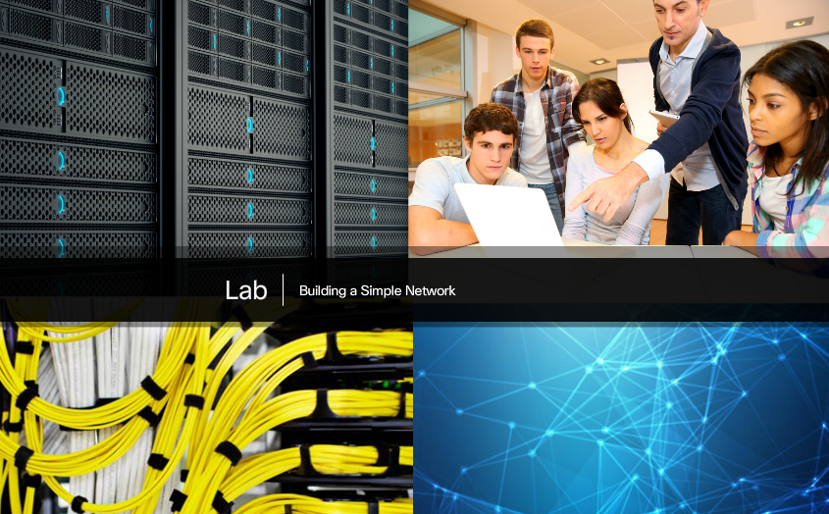

Lab - Building a Simple Network
In this lab, you will complete the following objectives:
- Part 1: Set Up the Network Topology (Ethernet only)
- Part 2: Configure PC Hosts
- Part 3: Configure and Verify Basic Switch Settings
Lab - Building a Simple Network

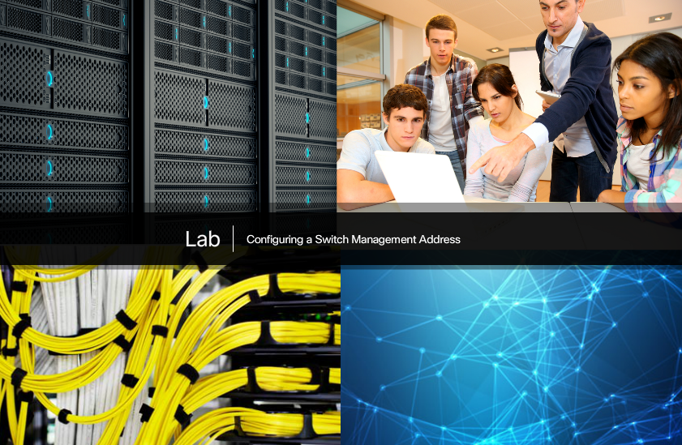

Lab - Configuring a Switch Management Address
In this lab, you will complete the following objectives:
- Part 1: Configure a Basic Network Device
- Part 2: Verify and Test Network Connectivity
Lab - Configuring a Switch Management Address

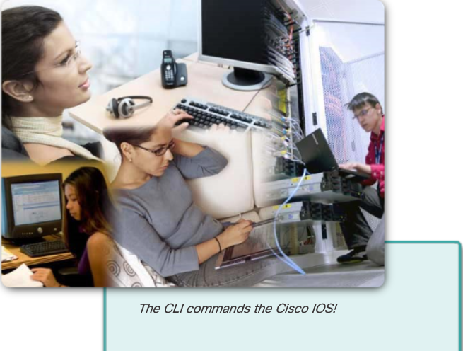

Class Activity - Tutor Me
Students will work in pairs. Packet Tracer is required for this activity.
Assume that a new colleague has asked you for an orientation to the Cisco IOS CLI. This colleague has never worked with Cisco devices before.
You explain the basic CLI commands and structure because you want your colleague to understand that the CLI is a simple, yet powerful, command language that can be easily understood and navigated.
Use Packet Tracer and one of the activities available in this chapter as a simple network model (for example, Lab - Configuring a Switch Management Address).
Focus on these areas:
- While the commands are technical, do they resemble any statements from plain English?
- How is the set of commands organized into subgroups or modes? How does an administrator know which mode he or she is currently using?
- What are the individual commands to configure the basic settings of a Cisco device? How would you explain this command in simple terms? Use parallels to real life whenever appropriate.
Suggest how to group different commands together according to their modes so that a minimum number of moves between modes will be needed.
Class Activity - Tutor Me! Instructions

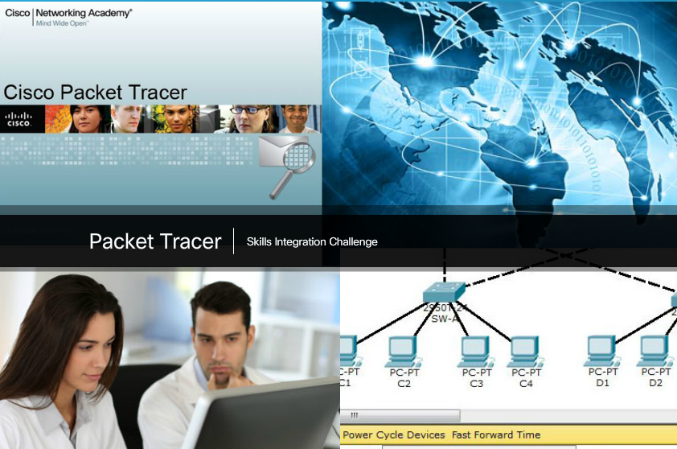

Packet Tracer - Skills Integration Challenge
As a recently hired LAN technician, your network manager has asked you to demonstrate your ability to configure a small LAN. Your tasks include configuring initial settings on two switches using the Cisco IOS and configuring IP address parameters on host devices to provide end-to-end connectivity. You are to use two switches and two hosts/PCs on a cabled and powered network.
Packet Tracer - Skills Integration Challenge Instructions
Packet Tracer - Skills Integration Challenge - PKA

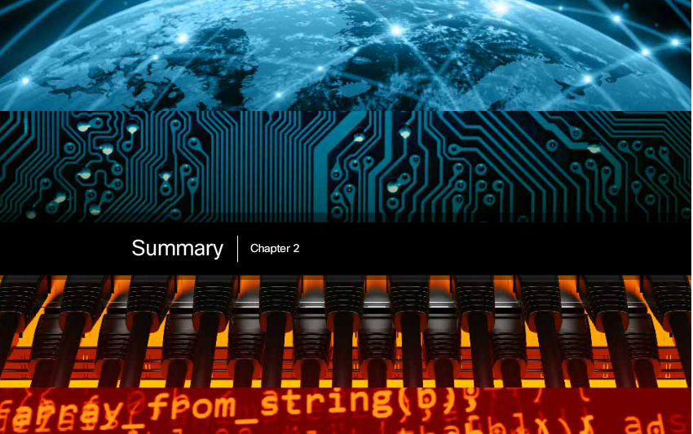

Chapter 2: Configure a Network Operating System
Cisco IOS is a term that encompasses a number of different operating systems, which runs on various networking devices. The technician can enter commands to configure, or program, the device to perform various networking functions. Cisco IOS routers and switches perform functions that network professionals depend upon to make their networks operate as expected.
The services provided by the Cisco IOS are accessed using a command-line interface (CLI), which is accessed by either the console port, the AUX port, or through SSH or Telnet. After connected to the CLI, network technicians can make configuration changes to Cisco IOS devices. The Cisco IOS is designed as a modal operating system, which means a network technician must navigate through various hierarchical modes of the IOS. Each mode supports different IOS commands.
Cisco IOS routers and switches support a similar modal operating system, support similar command structures, and support many of the same commands. In addition, both devices have identical initial configuration steps when implementing them in a network.
This chapter introduced the Cisco IOS. It detailed the various modes of the Cisco IOS and examined the basic command structure that is used to configure it. It also walked through the initial settings of a Cisco IOS switch device, including setting a name, limiting access to the device configuration, configuring banner messages, and saving the configuration.
The next chapter explores how packets are moved across the network infrastructure and introduce you to the rules of packet communication.

