Packet Tracer - Configure Layer 3 Switches(Instructor Version)

**Instructor Note:** Red font color or Gray highlights indicate text that appears in the instructor copy only.

1. Topology

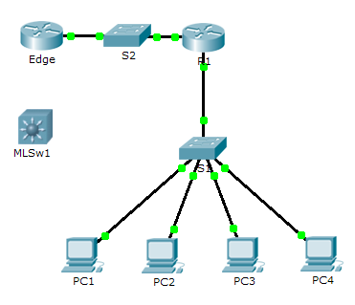

1. Addressing Table

|  |  |  |  |
| --- | --- | --- | --- |
| Device | Interface | IP Address | Subnet Mask |
| R1 | G0/0 | 172.16.31.1 | 255.255.255.0 |
| G0/1 | 192.168.0.2 | 255.255.255.0 |
| MLSw1 | G0/1 | 192.168.0.2 | 255.255.255.0 |
| VLAN 1 | 172.16.31.1 | 255.255.255.0 |

1. Objectives

Part 1: Document the Current Network Configurations

Part 2: Configure, Deploy, and Test the New Multilayer Switch

1. Scenario

The Network Administrator is replacing the current router and switch with a new Layer 3 switch. As the Network Technician, it is your job to configure the switch and place it into service. You will be working after hours to minimize disruption to the business.

**Note:** This activity begins with a score of 8/100, because the device connections for the PCs are scored. You will delete and restore these connections in Part 2. The scoring is there to verify that you correctly restored the connections.

1. Document the Current Network Configurations

**Note:** Normally a production router would have many more configurations than just interface IP addressing. However, to expedite this activity, only interface IP addressing is configured on **R1**.

* + 1. Click **R1** and then the **CLI** tab.
    2. Use the available commands to gather interface addressing information.
    3. Document the information in the **Addressing Table**.

1. Configure, Deploy, and Test the New Multilayer Switch
   1. Configure MLSw1 to use the addressing scheme from R1.
      1. Click **MLSw1** and then the **CLI** tab.
      2. Enter interface configuration mode for **GigabitEthernet 0/1**.
      3. Change the port to routing mode by entering the **no switchport** command.
      4. Configure the IP address to be the same as the address for **R1 GigabitEthernet 0/1** and activate the port.
      5. Enter interface configuration mode for **interface VLAN1**.
      6. Configure the IP address to be the same as the address for **R1 GigabitEthernet 0/0** and activate the port.
      7. Save the configuration.
   2. Deploy the new multilayer switch and verify that connectivity is restored.

**Note:** The following steps would normally be done after hours or when traffic on the production network is at its lowest volume. To minimize downtime, the new equipment should be fully configured and ready to deploy.

* + 1. Click an empty area of the screen to unselect all devices.
    2. Use the **Delete** tool to remove all the connections, or simply delete **R1**, **S1**, and **S2**.
    3. Select the appropriate cables to complete the following:
  1. Connect **MLSw1 GigabitEthernet 0/1** to the **Edge GigabitEthernet 0/0**.
  2. Connect the PCs to Fast Ethernet ports on **MLSw1**.
     1. Verify the PCs can all ping **Edge** at 192.168.0.1.

**Note:** Wait until orange link lights turn green.