Packet Tracer - Exploring Internetworking Devices (Instructor Version)

**Instructor Note**: Red font color or Gray highlights indicate text that appears in the instructor copy only.

1. Topology

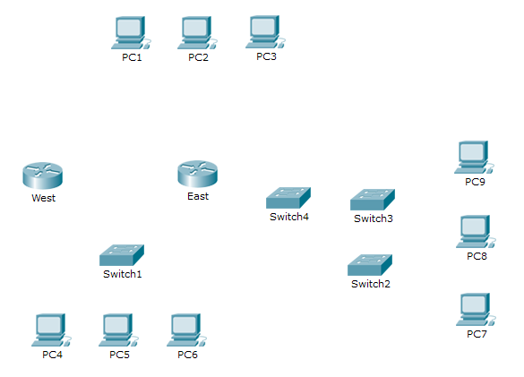

1. Objectives

Part 1: Identify Physical Characteristics of Internetworking Devices

Part 2: Select Correct Modules for Connectivity

Part 3: Connect Devices

1. Background

In this activity, you will explore the different options available on internetworking devices. You will also be required to determine which options provide the necessary connectivity when connecting multiple devices. Finally, you will add the correct modules and connect the devices.

**Note:** Scoring for this activity is a combination of Packet Tracer-automated scoring and your recorded answers to the questions posed in the instructions. See the Suggested Scoring Rubricat the end of this activity, and consult with your instructor to determine your final score.

1. Identify Physical Characteristics of Internetworking Devices
   1. Identify the management ports of a Cisco router.
      1. Click the **East** router. The **Physical** tab should be active.
      2. Zoom in and expand the window to see the entire router.
      3. Which management ports are available? AUX and Console ports
   2. Identify the LAN and WAN interfaces of a Cisco router
      1. Which LAN and WAN interfaces are available on the **East** router and how many are there? There are 2 WAN interfaces and 2 Gigabit Ethernet interfaces.
      2. Click the **CLI** tab and enter the following commands:

East> **show ip interface brief**

The output verifies the correct number of interfaces and their designation. The vlan1 interface is a virtual interface that only exists in software. How many physical interfaces are listed? 4

* + 1. Enter the following commands:

East> **show interface gigabitethernet 0/0**

What is the default bandwidth of this interface? 1000000 Kbit

East> **show interface serial 0/0/0**

What is the default bandwidth of this interface? 1544 Kbit

**Note:** Bandwidth on serial interfaces is used by routing processes to determine the best path to a destination. It does not indicate the actual bandwidth of the interface. Actual bandwidth is negotiated with a service provider.

* 1. Identify module expansion slots on switches.
     1. How many expansion slots are available to add additional modules to the **East** router? 1
     2. Click **Switch2** or **Switch3.** How many expansion slots are available? They each have 5 slots available

1. Select Correct Modules for Connectivity
   1. Determine which modules provide the required connectivity.
      1. Click **East** and then click the **Physical** tab. On the left, beneath the **Modules** label, you see the available options to expand the capabilities of the router. Click each module. A picture and a description displays at the bottom. Familiarize yourself with these options.
         1. You need to connect PCs 1, 2, and 3 to the **East** router, but you do not have the necessary funds to purchase a new switch. Which module can you use to connect the three PCs to the **East** router? HWIC-4ESW module
         2. How many hosts can you connect to the router using this module? 4
      2. Click **Switch2**. Which module can you insert to provide a Gigabit optical connection to **Switch3**? PT-SWITCH-NM-1FGE
   2. Add the correct modules and power up devices.
      1. Click **East** and attempt to insert the appropriate module from Step 1a.
      2. The Cannot add a module when the power is on message should display. Interfaces for this router model are not hot-swappable. The device must be turned off. Click the power switch located to the right of the Cisco logo to turn off **East**. Insert the appropriate module from Step 1a. When done, click the power switch to power up **East**.

**Note:** If you insert the wrong module and need to remove it, drag the module down to its picture in the bottom right corner, and release the mouse button.

* + 1. Using the same procedure, insert the appropriate modules from Step 1b in the empty slot farthest to the right in both **Switch2** and **Switch3**.
    2. Use the **show ip interface brief** command to identify the slot in which the module was placed.

Into which slot was it inserted? GigabitEthernet5/1

* + 1. Click the **West** router. The **Physical** tab should be active. Install the appropriate module that will add a serial interface to the enhanced high-speed WAN interface card (**eHWIC 0**) slot on the right. You can cover any unused slots to prevent dust from entering the router (optional).
    2. Use the appropriate command to verify that the new serial interfaces are installed.

1. Connect Devices

This may be the first activity you have done where you are required to connect devices. Although you may not know the purpose of the different cable types, use the table below and follow these guidelines to successfully connect all the devices:

* + 1. Select the appropriate cable type.
    2. Click the first device and select the specified interface.
    3. Click the second device and select the specified interface.
    4. If you correctly connected two devices, you will see your score increase.

**Example:** To connect **East** to **Switch1**, select the **Copper Straight-Through** cable type. Click **East** and choose **GigabitEthernet0/0**. Then, click **Switch1** and choose **GigabitEthernet1/1**. Your score should now be 4/52.

**Note:** For the purposes of this activity, link lights are disabled. The devices are not configured with any IP addressing, so you are unable to test connectivity.

|  |  |  |  |  |
| --- | --- | --- | --- | --- |
| **Device** | **Interface** | **Cable Type** | **Device** | **Interface** |
| East | GigabitEthernet0/0 | Copper Straight-Through | Switch1 | GigabitEthernet1/1 |
| East | GigabitEthernet0/1 | Copper Straight-Through | Switch4 | GigabitEthernet1/1 |
| East | FastEthernet0/1/0 | Copper Straight-Through | PC1 | FastEthernet0 |
| East | FastEthernet0/1/1 | Copper Straight-Through | PC2 | FastEthernet0 |
| East | FastEthernet0/1/2 | Copper Straight-Through | PC3 | FastEthernet0 |
| Switch1 | FastEthernet0/1 | Copper Straight-Through | PC4 | FastEthernet0 |
| Switch1 | FastEthernet0/2 | Copper Straight-Through | PC5 | FastEthernet0 |
| Switch1 | FastEthernet0/3 | Copper Straight-Through | PC6 | FastEthernet0 |
| Switch4 | GigabitEthernet1/2 | Copper Cross-Over | Switch3 | GigabitEthernet3/1 |
| Switch3 | GigabitEthernet5/1 | Fiber | Switch2 | GigabitEthernet5/1 |
| Switch2 | FastEthernet0/1 | Copper Straight-Through | PC7 | FastEthernet0 |
| Switch2 | FastEthernet1/1 | Copper Straight-Through | PC8 | FastEthernet0 |
| Switch2 | FastEthernet2/1 | Copper Straight-Through | PC9 | FastEthernet0 |
| East | Serial0/0/0 | Serial DCE (connect to East first) | West | Serial0/0/0 |

1. Suggested Scoring Rubric

|  |  |  |  |
| --- | --- | --- | --- |
| Activity Section | Question Location | Possible Points | Earned Points |
| Part 1: Identify Physical Characteristics of Internetworking Devices | Step 1c | 4 |  |
| Step 2a | 4 |  |
| Step 2b | 4 |  |
| Step 2c, q1 | 4 |  |
| Step 2c, q2 | 4 |  |
| Step 3a | 4 |  |
| Step 3b | 4 |  |
| **Part 1 Total** | | **28** |  |
| Part 2: Select Correct Modules for Connectivity | Step 1a, q1 | 5 |  |
| Step 1a, q2 | 5 |  |
| Step 1b | 5 |  |
| Step 2d | 5 |  |
| **Part 2 Total** | | **20** |  |
| **Packet Tracer Score** | | **52** |  |
| **Total Score** | | **100** |  |