Packet Tracer - Web and Email Servers (Instructor Version)

**Instructor Note:** Red font color or Gray highlights indicate text that appears in the instructor copy only.

1. Topology

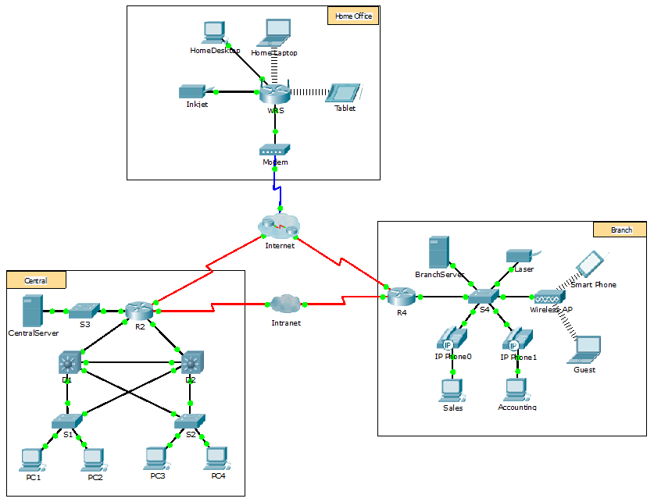

Objectives

Part 1: Configure and Verify Web Services

Part 2: Configure and Verify Email Services

1. Background

In this activity, you will configure HTTP and email services using the simulated server in Packet Tracer. You will then configure clients to access the HTTP and email services.

**Note:** Packet Tracer only simulates the process for configuring these services. HTTP and email software packages each have their own unique installation and configuration instructions.

1. Configure and Verify Web Services
   1. Configure web services on CentralServer and BranchServer.
      1. Click **CentralServer** and click the **Config** tab > **HTTP**.
      2. Click **On** to enable HTTP and HTTP Secure (HTTPS).
      3. Optional. Personalize the HTML code.
      4. Repeat Step1a – 1c on **BranchServer**.
   2. Verify the web servers by accessing the web pages.

There are many endpoint devices in this network, but for the purposes of this step, use **PC3**.

* + 1. Click **PC3** and click the **Desktop** tab > **Web Browser**.
    2. In the URL box, enter **10.10.10.2** as the IP address and click **Go**. The **CentralServer** website displays.
    3. In the URL box, enter **64.100.200.1** as the IP address and click **Go**. The **BranchServer** website displays.
    4. In the URL box, enter **centralserver.pt.pka** and click **Go**. The **CentralServer** website displays.
    5. In the URL box, enter **branchserver.pt.pka** and click **Go**. The **BranchServer** website displays.
    6. What protocol is translating the **centralserver.pt.pka** and **branchserver.pt.pka** names to IP addresses? Domain Name Service (DNS)

1. Configure and Verify Email Services on Servers
   1. Configure CentralServer to send (SMTP) and receive (POP3) Email.
      1. Click **CentralServer**, and then select the **Config** tab followed by the **EMAIL** button.
      2. Click **On** to enable the SMTP and POP3.
      3. Set the domain name to **centralserver.pt.pka** and click **Set**.
      4. Create a user named **central-user** with password **cisco**. Click **+** to add the user.
   2. Configure BranchServer to send (SMTP) and receive (POP3) Email.
      1. Click **BranchServer** and click the **Config** tab > **EMAIL**.
      2. Click **On** to enable SMTP and POP3.
      3. Set the domain name to **branchserver.pt.pka** and click **Set**.
      4. Create a user named **branch-user** with password **cisco**. Click **+** to add the user.
   3. Configure PC3 to use the CentralServer email service.
      1. Click **PC3** and click the **Desktop** tab > **E Mail**.
      2. Enter the following values into their respective fields:
         1. Your Name: **Central User**
         2. Email Address: **central-user@centralserver.pt.pka**
         3. Incoming Mail Server: **10.10.10.2**
         4. Outgoing Mail Server: **10.10.10.2**
         5. User Name: **central-user**
         6. Password: **cisco**
      3. Click **Save**. The Mail Browser window displays.
      4. Click **Receive**. If everything has been set up correctly on both the client and server, the Mail Browser window displays the Receive Mail Success message confirmation.
   4. Configure Sales to use the Email service of BranchServer.
      1. Click **Sales** and click the **Desktop** tab > **E Mail**.
      2. Enter the following values into their respective fields:
         1. Your Name: **Branch User**
         2. Email Address: **branch-user@branchserver.pt.pka**
         3. Incoming Mail Server: **172.16.0.3**
         4. Outgoing Mail Server: **172.16.0.3**
         5. User Name: **branch-user**
         6. Password: **cisco**
      3. Click **Save**. The Mail Browser window displays.
      4. Click **Receive**. If everything has been set up correctly on both the client and server, the Mail Browser window displays the Receive Mail Success message confirmation.
      5. The activity should be 100% complete. Do not close the Sales configuration window or the Mail Browser window.
   5. Send an Email from the Sales client and the PC3 client.
      1. From the **Sales** **Mail Browser** window, click **Compose**.
      2. Enter the following values into their respective fields:
         1. To: **central-user@centralserver.pt.pka**
         2. Subject: *Personalize the subject line*.
         3. **Email** Body: *Personalize the email*.
      3. Click **Send**.
      4. Verify that **PC3** received the email. Click **PC3**. If the Mail Browser window is closed, click **E Mail**.
      5. Click **Receive**. An email from Sales displays. Double-click the email.
      6. Click **Reply**, personalize a response, and click **Send**.
      7. Verify that **Sales** received the reply.