Packet Tracer - Network Representation (Instructor Version)

**Instructor Note:** Red font color or Gray highlights indicate text that appears in the instructor copy only.

All clients have full connectivity to the servers. For the sake of frame diversity, the environment is not entirely realistic. For instance:

* NAT and PAT overload are both being used on the Branch network, but the Central 10.X.X.X network is being shared publicly.
* There is a separate DNS server in the 172 network due to the inability of computers to use the file server's public address. The simulated DNS server, unlike BIND, is basic and does not forward requests that it does not know to a root server - so the A records are duplicated.
* EIGRP is running in the cloud, as opposed to BGP.
* The Branch switch is actually providing DHCP, just because it can. It makes that side of the simulation different than the Central side.
* The cloud includes two servers, one of which uses the correct IP of netacad.com, and the other uses the correct IP of Google's DNS.
* The router passwords are "cisco" and "class", but there is a "banner motd" and "banner login" which readily give the passwords to the curious.
* The S1 and S2 switches have spanning tree PVST enabled. Each has a different blocking port, so all connections are green.

1. Topology

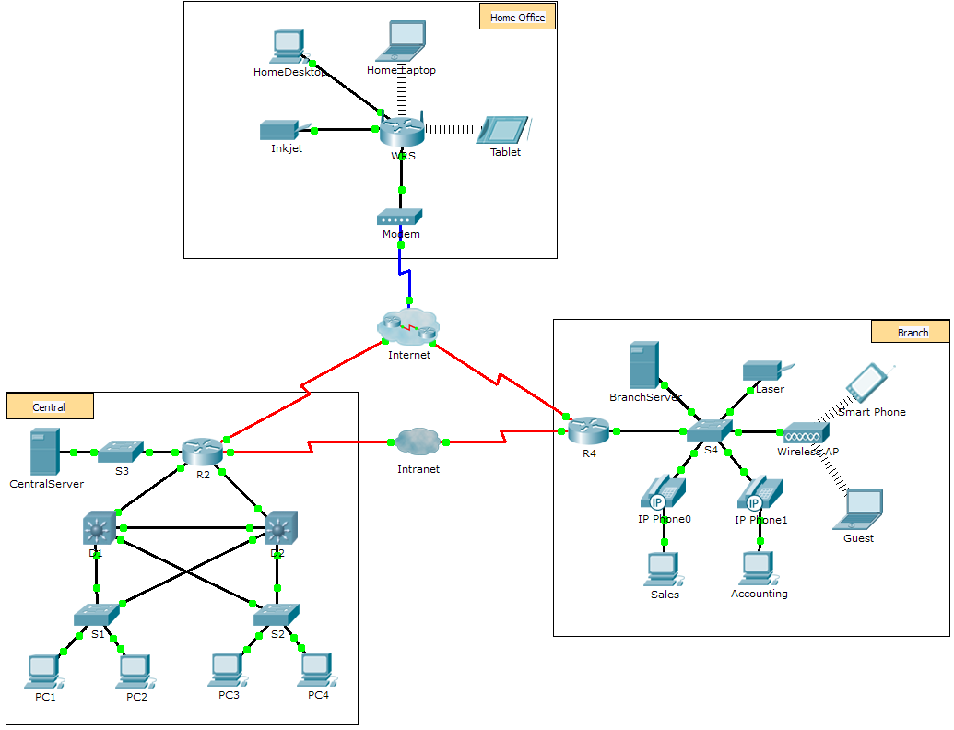

1. Objectives

Part 1: Overview of the Packet Tracer Program

Part 2: Exploring LANs, WANs, and Internets

1. Background

Packet Tracer is a fun, take-home, flexible software program which will help you with your Cisco Certified Network Associate (CCNA) studies. Packet Tracer allows you to experiment with network behavior, build network models, and ask "what if" questions. In this activity, you will explore a relatively complex network that highlights a few of Packet Tracer’s features. While doing so, you will learn how to access Help and the tutorials. You will also learn how to switch between various modes and workspaces. Finally, you will explore how Packet Tracer serves as a modeling tool for network representations.

**Note**: It is not important that you understand everything you see and do in this activity. Feel free to explore the network on your own. If you wish to proceed more systematically, follow the steps below. Answer the questions to the best of your ability.

1. Overview of the Packet Tracer Program

The network size is larger than most of the networks you will experience in this course (although you will see this topology often in your Networking Academy studies). You may need to adjust the window size of Packet Tracer to see the full network. If necessary, you can use the zoom in and out tools to adjust the size of the Packet Tracer window.

* 1. Access the Packet Tracer Help pages, tutorial videos, and online resources
     1. Access the Packet Tracer Help pages in two ways:
        1. Click the question mark icon in the top, right-hand corner of the menu toolbar.
        2. Click the **Help** menu, and then choose **Contents**.
     2. Access the Packet Tracer tutorial videos by clicking **Help** > **Tutorials**. These videos are a visual demonstration of the information found in the **Help** pages and various aspects of the Packet Tracer software program. Before proceeding with this activity, you should gain some familiarity with the Packet Tracer interface and Simulation mode.
        1. View the **Interface Overview** video in the **Getting Started** section of Tutorials.
        2. View the **Simulation Environment** video in the **Realtime and Simulation Modes** section of **Tutorials**.
     3. Find the “Configuring Devices Using the Desktop Tab” tutorial. Watch the first part to answer the following question: What information can you configure in the IP Configuration window? You can choose DHCP or Static and configure the IP address, Subnet Mask, Default Gateway, and DNS Server.
  2. Toggle between Realtime and Simulation modes.
     1. Find the **Realtime** word in the bottom right corner of the Packet Tracer interface. In Realtime mode, your network is always running like a real network, whether you are working on the network or not. Your configurations are done in real time, and the network responds in near real time.
     2. Click the tab directly behind the **Realtime** tab to switch to **Simulation** mode. In Simulation mode, you can watch your network run at a slower pace, observing the paths that data takes and inspecting the data packets in detail.
     3. In the Simulation Panel, click **Auto Capture / Play**. You should now see data packets, represented as envelopes of various colors, traveling between the devices.
     4. Click **Auto Capture / Play** again to pause the simulation.
     5. Click **Capture / Forward** to step through the simulation. Click the button a few more times to see the effect.
     6. In the network topology on the left, click one of the envelopes on an intermediate device and investigate what is inside. Over the course of your CCNA studies, you will learn the meaning of most everything inside these envelopes. For now, see if you can answer the following questions:
  3. Under the **OSI Model tab**, how many **In Layers** and **Out Layers** have information? Answers will vary depending on the layer of the device.
  4. Under the **Inbound PDU Details** and **Outbound PDU Details** tabs, what are the headings of the major sections? Answers will vary, but some likely answers will be Ethernet 802.3, LLC, STP BPDU, etc.
  5. Click back and forth between the **Inbound PDU Details** and **Outbound PDU Details** tabs. Do you see information changing? If so, what? Answers will vary, but the source and/or destination addresses in the data link layer are changing. Other data may be changing as well depending on which packet the student chose to open.
     1. Click the toggle button above **Simulation** in the bottom right corner to return to **Realtime** mode.
  6. Toggle between Logical and Physical views.
     1. Find the **Logical** word in the top left corner of the Packet Tracer interface. You are currently in the **Logical** workspace where you will spend the majority of your time building, configuring, investigating, and troubleshooting networks.

**Note:** Although you can add a geographical map as the background image for the **Logical** workspace, it does not usually have any relationship to the actual physical location of devices.

* + 1. Click the tab below **Logical** to switch to the **Physical** workspace. The purpose of the **Physical** workspace is to give a physical dimension to your Logical network topology. It gives you a sense of scale and placement (how your network might look in a real environment).
    2. During your CCNA studies, you will use this workspace on occasion. For now, just know that it is here and available for you to use. To learn more about the Physical workspace, refer to the Help files and tutorial videos.
    3. Click the toggle button below **Physical** in the top right corner to return to the **Logical** workspace.

1. Exploring LANs, WANs, and Internets

The network model in this activity incorporates many of the technologies that you will master in your CCNA studies. It represents a simplified version of how a small to medium-sized business network might look. Feel free to explore the network on your own. When ready, proceed through the following steps and answer the questions.

* 1. Identify common components of a network as represented in Packet Tracer.
     1. The Icon toolbar has various categories of networking components. You should see categories that correspond to intermediate devices, end devices, and media. The **Connections** category (with the lightning bolt icon) represents the networking media supported by Packet Tracer. There is also an **End Devices** category and two categories specific to Packet Tracer: **Custom Made Devices** and **Multiuser Connection**.
     2. List the intermediate device categories. Routers, Switches, Hubs, Wireless Devices, and WAN Emulation
     3. Without entering into the Internet cloud or Intranet cloud, how many icons in the topology represent endpoint devices (only one connection leading to them)? 13
     4. Without counting the two clouds, how many icons in the topology represent intermediate devices (multiple connections leading to them)? 11
     5. How many intermediate devices are routers? Note: The Linksys device is a router. 5
     6. How many end devices are **not** desktop computers? 8
     7. How many different types of media connections are used in this network topology? 4
     8. Why isn’t there a connection icon for wireless in the Connections category? Wireless connections are not physically made by the network technician. Instead, the devices are responsible for negotiating the connection and bringing up the physical link.
  2. Explain the purpose of the devices.
     1. In Packet Tracer, the Server-PT device can act as a server. The desktop and laptop PCs cannot act as a server. Is that true in the real world? No.   
        Based on your studies so far, explain the client-server model. In modern networks, a host can act as a client, a server, or both. Software installed on the host determines which role it plays on the network. Servers are hosts that have software installed that enables them to provide information and services, like email or web pages, to other hosts on the network. Clients are hosts that have software installed that enables them to request and display the information obtained from the server. But a client could also be configured as a server simply by installing server software.
     2. List at least two functions of intermediary devices. Regenerate and retransmit data signals; maintain information about what pathways exist through the network and internetwork; Notify other devices of errors and communication failures; Direct data along alternate pathways when there is a link failure; Classify and direct messages according to QoS priorities; Permit or deny the flow of data, based on security settings.
     3. List at least two criteria for choosing a network media type. The distance the media can successfully carry a signal. The environment in which the media is to be installed. The amount of data and the speed at which it must be transmitted. The cost of the media and installation.
  3. Compare and contrast LANs and WANs.
     1. Explain the difference between a LAN and a WAN. Give examples of each. LANs provide access to end users in a small geographical area. A home office or school campus are examples of LANs. WANs provide access to users in a wide geographical area over long distances spanning a few miles to thousands of miles. A Metropolitan Area Network and the Internet are examples of WANs. A company’s intranet may also connect multiple remote sites using a WAN.
     2. In the Packet Tracer network, how many WANs do you see? There are two: the Internet and the Intranet WANs.
     3. How many LANs do you see? There are three, easily identifiable because each has a border and label.
     4. The Internet in this Packet Tracer network is overly simplified and does not represent the structure and form of the real Internet. Briefly describe the Internet. The Internet is mostly used when we need to communicate with a resource on another network. The Internet is a global mesh of interconnected networks (internetworks).
     5. What are some of the common ways a home user connects to the Internet? Cable, DSL, dial-up, cellular, and satellite.
     6. What are some common methods that businesses use to connect to the Internet in your area? Dedicated leased line, Metro-E, DSL, Cable, Satellite

1. Challenge

Now that you have had an opportunity to explore the network represented in this Packet Tracer activity, you may have picked up a few skills that you would like to try out. Or maybe you would like the opportunity to explore this network in more detail. Realizing that most of what you see and experience in Packet Tracer is currently beyond your skill level, here are some challenges you might want to attempt. Do not worry if you cannot do them all. You will be a Packet Tracer master user and network designer soon enough.

* Add an end device to the topology and connect it to one of the LANs with a media connection. What else does this device need to send data to other end users? Can you provide the information? Is there a way to verify that you correctly connected the device?
* Add a new intermediary device to one of the networks and connect it to one of the LANs or WANs with a media connection. What else does this device need to serve as an intermediary to other devices in the network?
* Open a new instance of Packet Tracer. Create a new network with at least two LANs connected by a WAN. Connect all the devices. Investigate the original Packet Tracer activity to see what else you might need to do to make your new network functional. Record your thoughts and save your Packet Tracer file. You may want to revisit your network later after you have mastered a few more skills.

1. Suggested Scoring Rubric

|  |  |  |  |
| --- | --- | --- | --- |
| Activity Section | Question Location | Possible Points | Earned Points |
| Part 1: Overview of the Packet Tracer Program | Step 1c | 4 |  |
| Step 2f | 6 |  |
| **Part 1 Total** | | **10** |  |
| Part 2: Exploring LANs, WANs, and Internets | Step 1b | 5 |  |
| Step 1c | 5 |  |
| Step 1d | 5 |  |
| Step 1e | 5 |  |
| Step 1f | 5 |  |
| Step 1g | 5 |  |
| Step 1h | 6 |  |
| Step 2a | 6 |  |
| Step 2b | 6 |  |
| Step 2c | 6 |  |
| Step 3a | 6 |  |
| Step 3b | 6 |  |
| Step 3c | 6 |  |
| Step 3d | 6 |  |
| Step 3e | 6 |  |
| Step 3f | 6 |  |
| **Part 2 Total** | | **90** |  |
| **Total Score** | | **100** |  |