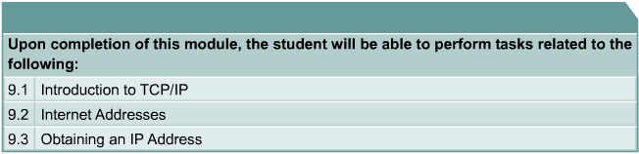
The Internet was developed to provide a communication network that could continue to function in wartime. Although the Internet has evolved in ways very different from those imagined by its architects, it is still based on the TCP/IP protocol suite. The design of TCP/IP is ideal for the decentralized and robust network that is the Internet. Many protocols used today were designed using the four-layer TCP/IP model.
It is useful to know both the TCP/IP and OSI networking models. Each model offers its own structure for explaining how a network works but there is much overlap between the two. Without an understanding of both, a system administrator may not have sufficient insight into why a network functions the way it does.
Any device on the Internet that wants to communicate with other Internet devices must have a unique identifier. The identifier is known as the IP address because routers use a layer three protocol, the IP protocol, to find the best route to that device. IPv4, the current version of IP, was designed before there was a large demand for addresses. Explosive growth of the Internet has threatened to deplete the supply of IP addresses. Subnetting, Network Address Translation (NAT) and private addressing are used to extend IP addressing without exhausting the supply. Another version of IP known as IPv6 improves on the current version providing a much larger address space, integrating or eliminating the methods used to work with the shortcomings of IPv4.
In addition to the physical MAC address, each computer needs a unique IP address, sometimes called logical address, to be part of the Internet. There are several methods of assigning an IP address to a device. Some devices always have a static address, while others have a temporary address assigned to them every time they connect to the network. When a dynamically assigned IP address is needed, the device can obtain it using several methods.
For efficient routing to occur between devices, other issues must be resolved. For example, duplicate IP addresses can stop efficient routing of data.
Students completing this module should be able to:
- Explain why the Internet was developed and how TCP/IP fits the design of the Internet.
- List the four layers of the TCP/IP model.
- Describe the functions of each layer of the TCP/IP model.
- Compare the OSI model and the TCP/IP model.
- Describe the function and structure of IP addresses.
- Understand why subnetting is necessary.
- Explain the difference between public and private addressing.
- Understand the function of reserved IP addresses.
- Explain the use of static and dynamic addressing for a device.
- Understand how dynamic addressing can be done using RARP, BootP and DHCP.
- Use ARP to obtain the MAC address to send a packet to another device.
- Understand the issues related to addressing between networks.
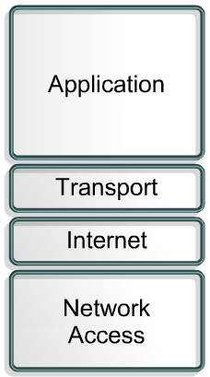
The U.S. Department of Defense (DoD) created the TCP/IP reference model because it wanted a network that could survive any conditions. To illustrate further, imagine a world, crossed by multiple cable runs, wires, microwaves, optical fibers, and satellite links. Then imagine a need for data to be transmitted without regard for the condition of any particular node or network. The DoD required reliable data transmission to any destination on the network under any circumstance. The creation of the TCP/IP model helped to solve this difficult design problem. The TCP/IP model has since become the standard on which the Internet is based.
In reading about the layers of the TCP/IP model layers, keep in mind the original intent of the Internet. Remembering the intent will help reduce confusion. The TCP/IP model has four layers: the application layer, transport layer, Internet layer, and the network access layer. Some of the layers in the TCP/IP model have the same name as layers in the OSI model. It is critical not to confuse the layer functions of the two models because the layers include different functions in each model.
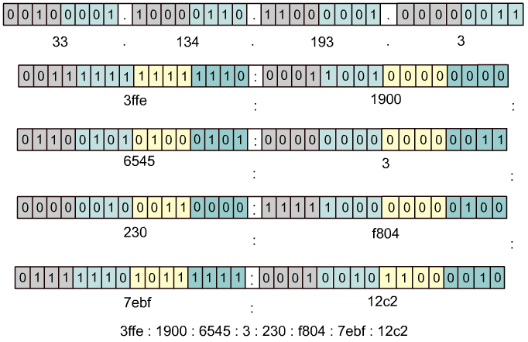

The present version of TCP/IP was standardized in September of 1981. As shown in Figure , IPv4 addresses are 32 bits long, written in dotted decimal, and separated by periods. IPv6 addresses are 128 bits long, written in hexadecimal, and separated by colons. Colons separate 16-bit fields. Leading zeros can be omitted in each field as can be seen in the Figure where the field :0003: is written :3:. In 1992 the standardization of a new generation of IP, often called IPng, was supported by the Internet Engineering Task Force (IETF). IPng is now known as IPv6. IPv6 has not gained wide implementation, but it has been released by most vendors of networking equipment and will eventually become the dominant standard.
History of the Internet
http://www.itep.co.ae/itportal/english/ Content/EducationalCenter/ InternetConcepts/ history_future.asp
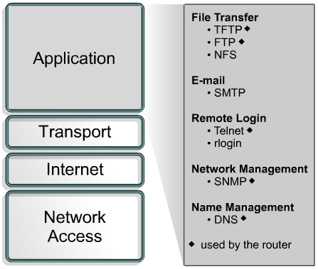
The application layer of the TCP/IP model handles high-level protocols, issues of representation, encoding, and dialog control. The TCP/IP protocol suite combines all application related issues into one layer and assures this data is properly packaged before passing it on to the next layer. TCP/IP includes not only Internet and transport layer specifications, such as IP and TCP, but also specifications for common applications. TCP/IP has protocols to support file transfer, e-mail, and remote login, in addition to the following applications:
- File Transfer Protocol (FTP) – FTP is a reliable, connection-oriented service that uses TCP to transfer files between systems that support FTP. It supports bi-directional binary file and ASCII file transfers.
- Trivial File Transfer Protocol (TFTP) – TFTP is a connectionless service that uses the User Datagram Protocol (UDP). TFTP is used on the router to transfer configuration files and Cisco IOS images, and to transfer files between systems that support TFTP. It is useful in some LANs because it operates faster than FTP in a stable environment.
- Network File System (NFS) – NFS is a distributed file system protocol suite developed by Sun Microsystems that allows file access to a remote storage device such as a hard disk across a network.
- Simple Mail Transfer Protocol (SMTP) – SMTP administers the transmission of e-mail over computer networks. It does not provide support for transmission of data other than plaintext.
- Terminal emulation (Telnet) – Telnet provides the capability to remotely access another computer. It enables a user to log in to an Internet host and execute commands. A Telnet client is referred to as a local host. A Telnet server is referred to as a remote host.
- Simple Network Management Protocol (SNMP) – SNMP is a protocol that provides a way to monitor and control network devices, and to manage configurations, statistics collection, performance, and security.
- Domain Name System (DNS) – DNS is a system used on the Internet for translating names of domains and their publicly advertised network nodes into IP addresses.
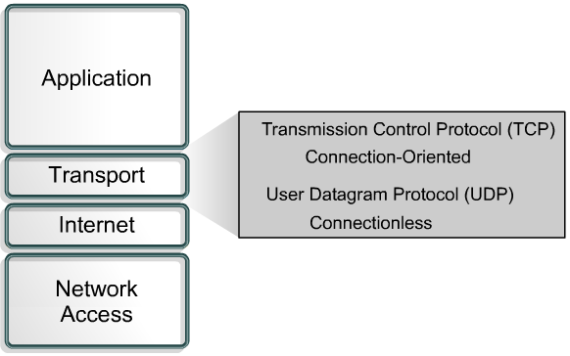
The transport layer provides transport services from the source host to the destination host. The transport layer constitutes a logical connection between the endpoints of the network, the sending host and the receiving host. Transport protocols segment and reassemble upper-layer applications into the same data stream between endpoints. The transport layer data stream provides end-to-end transport services.
The Internet is often represented by a cloud. The transport layer sends data packets from the sending source to the receiving destination through the cloud. End-to-end control, provided by sliding windows and reliability in sequencing numbers and acknowledgments, is the primary duty of the transport layer when using TCP. The transport layer also defines end-to-end connectivity between host applications. Transport services include all the following services:
TCP and UDP
- Segmenting upper-layer application data
- Sending segments from one end device to another end device
TCP only
- Establishing end-to-end operations
- Flow control provided by sliding windows
- Reliability provided by sequence numbers and acknowledgments
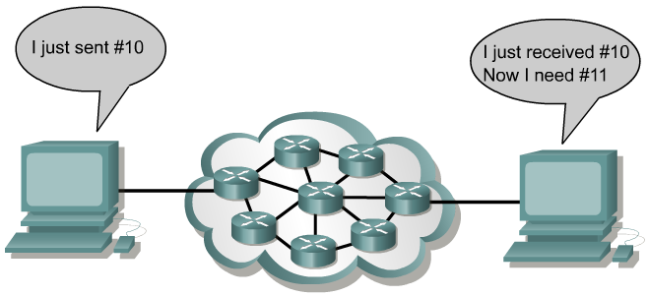
The Internet is often represented by a cloud. The transport layer sends data packets from the sending source to the receiving destination through the cloud. The cloud deals with issues such as “Which of several paths is best for a given route?”

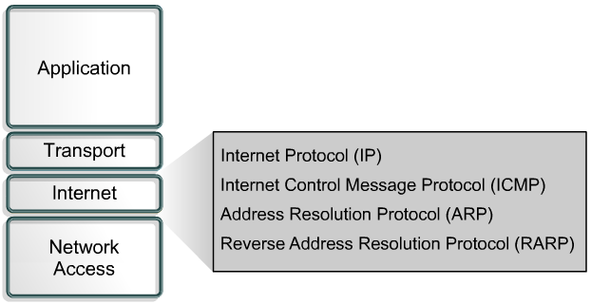
The purpose of the Internet layer is to select the best path through the network for packets to travel. The main protocol that functions at this layer is the Internet Protocol (IP). Best path determination and packet switching occur at this layer.
The following protocols operate at the TCP/IP Internet layer:
- IP provides connectionless, best-effort delivery routing of packets. IP is not concerned with the content of the packets but looks for a path to the destination.
- Internet Control Message Protocol (ICMP) provides control and messaging capabilities.
- Address Resolution Protocol (ARP) determines the data link layer address, MAC address, for known IP addresses.
- Reverse Address Resolution Protocol (RARP) determines IP addresses when the MAC address is known.
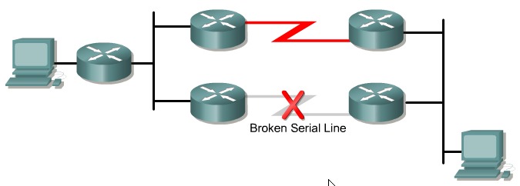
IP performs the following operations:
- Defines a packet and an addressing scheme
- Transfers data between the Internet layer and network access layers
- Routes packets to remote hosts
Finally, as a clarification of terminology, IP is sometimes referred to as an unreliable protocol. This does not mean that IP will not accurately deliver data across a network. Calling IP an unreliable protocol simply means that IP does not perform error checking and correction. That function is handled by upper layer protocols from the transport or application layers
Internet Layer
http://www.pku.edu.cn/academic/research/ computer-center/tc/html/TC0300.html
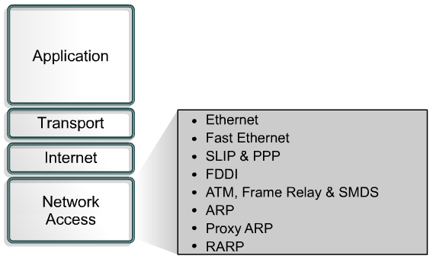
The network access layer is also called the host-to-network layer. The network access layer is the layer that is concerned with all of the issues that an IP packet requires to actually make a physical link to the network media. It includes the LAN and WAN technology details, and all the details contained in the OSI physical and data-link layers.
Drivers for software applications, modem cards and other devices operate at the network access layer. The network access layer defines the procedures for interfacing with the network hardware and accessing the transmission medium. Modem protocol standards such as Serial Line Internet Protocol (SLIP) and Point-to-Point Protocol (PPP) provide network access through a modem connection. Because of an intricate interplay of hardware, software, and transmission-medium specifications, there are many protocols operating at this layer. This can lead to confusion for users. Most of the recognizable protocols operate at the transport and Internet layers of the TCP/IP model.
Network access layer functions include mapping IP addresses to physical hardware addresses and encapsulation of IP packets into frames. Based upon the hardware type and the network interface, the network access layer will define the connection with the physical network media.
A good example of network access layer configuration would be to set up a Windows system using a third party NIC. Depending on the version of Windows, the NIC would automatically be detected by the operating system and then the proper drivers would be installed. If this were an older version of Windows, the user would have to specify the network card driver. The card manufacturer supplies these drivers on disks or CD-ROMs

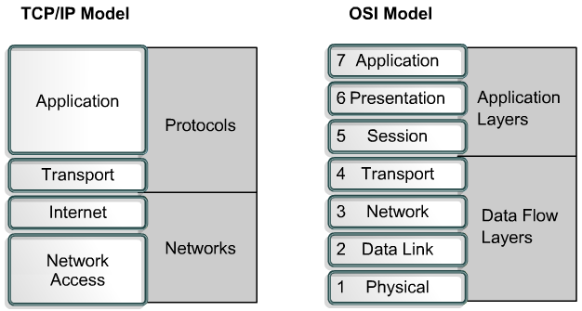
The following is a comparison of the OSI model and the TCP/IP model noting the similarities and differences:
Similarities of the OSI and TCP/IP models:
- Both have layers
- Both have application layers, though they include very different services
- Both have comparable transport and network layers
- Packet-switched, not circuit-switched, technology is assumed
- Networking professionals need to know both models
Differences of the OSI and TCP/IP models:
- TCP/IP combines the presentation and session layer into its application layer
- TCP/IP combines the OSI data link and physical layers into one layer
- TCP/IP appears simpler because it has fewer layers
- TCP/IP transport layer using UDP does not always guarantee reliable delivery of packets as the transport layer in the OSI model does
The Internet is developed by the standards of the TCP/IP protocols. The TCP/IP model gains credibility because of its protocols. In contrast, networks typically are not built on the OSI protocol. The OSI model is used as a guide for understanding the communication process.

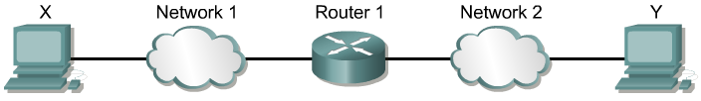
While the Internet is complex, there are some basic ideas in its operation. In this section the basic architecture of the Internet will be examined. The Internet is a deceptively simple idea, that when repeated on a large scale, enables nearly instantaneous worldwide data communications between anyone, anywhere, at any time.
LANs are smaller networks limited in geographic area. Many LANs connected together allow the Internet to function. But LANs have limitations in scale. Although there have been technological advances to improve the speed of communications, such as Metro Optical, Gigabit, and 10-Gigabit Ethernet, distance is still a problem.
Focusing on the communication between the source and destination computer and intermediate computers at the application layer is one way to get an overview of the Internet architecture. Placing identical instances of an application on all the computers in the network could ease the delivery of messages across the large network. However, this does not scale well. For new software to function properly, it would require new applications installed on every computer in the network. For new hardware to function properly, it would require modifying the software. Any failure of an intermediate computer or the application of the computer would cause a break in the chain of the messages that are passed.
The Internet uses the principle of network layer interconnection. Using the OSI model as an example, the goal is to build the functionality of the network in independent modules. This allows a diversity of LAN technologies at Layers 1 and 2 and a diversity of applications functioning at Layers 5, 6, and 7. The OSI model provides a mechanism where the details of the lower and the upper layers are separated. This allows intermediate networking devices to “relay” traffic without having to bother with the details of the LAN.
This leads to the concept of internetworking, or building networks of networks. A network of networks is called an internet, indicated with the lowercase “i”. When referring to the networks that developed from the DoD on which the Worldwide Web (www) runs, the uppercase “I” is used and is called the Internet. Internetworking must be scalable with regard to the number of networks and computers attached. Internetworking must be able to handle the transport of data across vast distances. It must be flexible to account for constant technological innovations. It must be able to adjust to dynamic conditions on the network. And internetworks must be cost-effective. Internetworks must be designed to permit anytime, anywhere, data communications to anyone.
Figure summarizes the connection of one physical network to another through a special purpose computer called a router. These networks are described as directly connected to the router. The router is needed to handle any path decisions required for the two networks to communicate. Many routers are needed to handle large volumes of network traffic
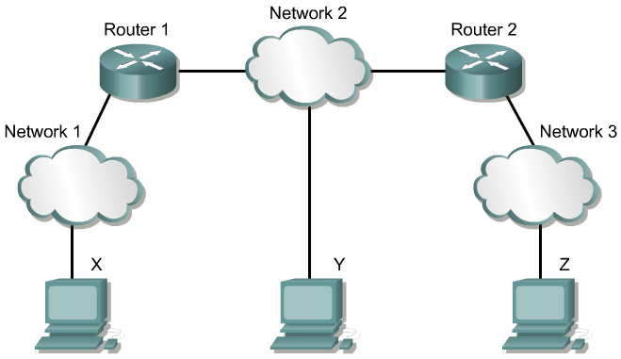
Figure extends the idea to three physical networks connected by two routers. Routers make complex decisions to allow all the users on all the networks to communicate with each other. Not all networks are directly connected to one another. The router must have some method to handle this situation.
One option is for a router to keep a list of all computers and all the paths to them. The router would then decide how to forward data packets based on this reference table. The forwarding is based on the IP address of the destination computer. This option would become difficult as the number of users grows. Scalability is introduced when the router keeps a list of all networks, but leaves the local delivery details to the local physical networks. In this situation, the routers pass messages to other routers. Each router shares information about which networks it is connected to. This builds the routing table.
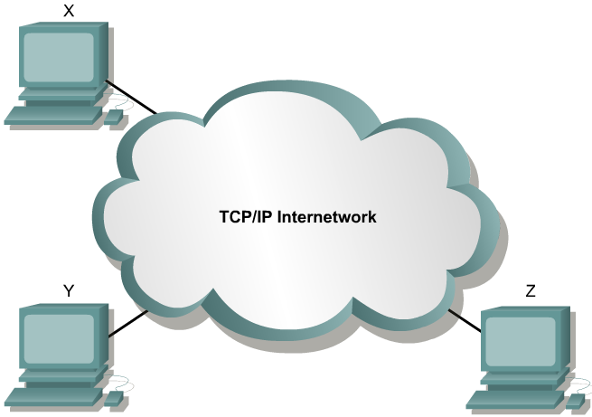

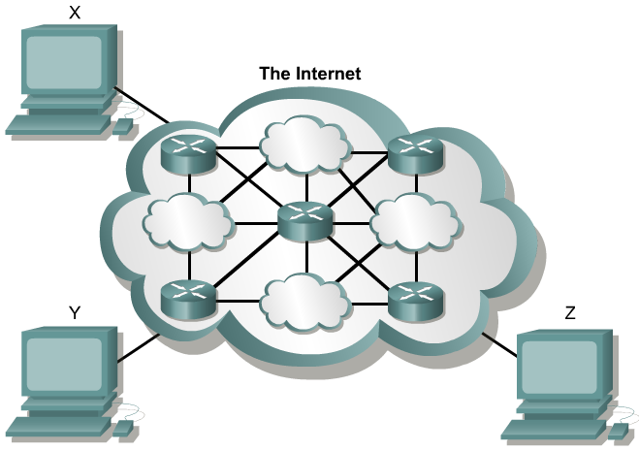
Figure shows the transparency that users require. Yet, the physical and logical structures inside the Internet cloud can be extremely complex as displayed in Figure . The Internet has grown rapidly to allow more and more users. The fact that the Internet has grown so large with more than 90,000 core routes and 300,000,000 end users is proof of the soundness of the Internet architecture.
Two computers, anywhere in the world, following certain hardware, software, and protocol specifications, can communicate reliably. Standardization of practices and procedures for moving data across networks has made the Internet possible
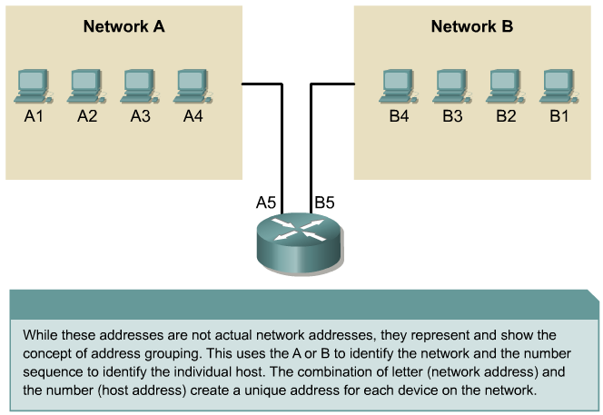
For any two systems to communicate, they must be able to identify and locate each other. While these addresses in Figure are not actual network addresses, they represent and show the concept of address grouping. This uses the A or B to identify the network and the number sequence to identify the individual host
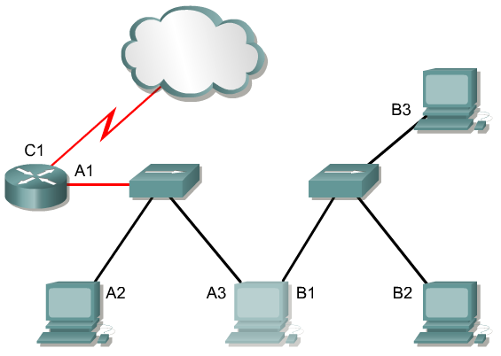
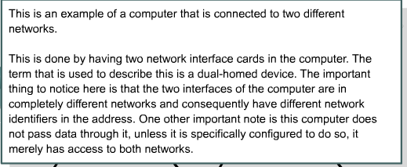
A computer may be connected to more than one network. In this situation, the system must be given more than one address. Each address will identify the connection of the computer to a different network. A device is not said to have an address, but that each of the connection points, or interfaces, on that device has an address to a network. This will allow other computers to locate the device on that particular network. The combination of letter (network address) and the number (host address) create a unique address for each device on the network. Each computer in a TCP/IP network must be given a unique identifier, or IP address. This address, operating at Layer 3, allows one computer to locate another computer on a network. All computers also have a unique physical address, known as a MAC address. These are assigned by the manufacturer of the network interface card. MAC addresses operate at Layer 2 of the OSI model.

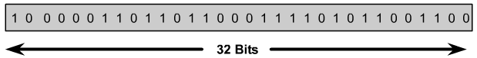
An IP address is a 32-bit sequence of 1s and 0s. Figure shows a sample 32-bit number. To make the IP address easier to use, the address is usually written as four decimal numbers separated by periods. For example, an IP address of one computer is 192.168.1.2. Another computer might have the address 128.10.2.1. This way of writing the address is called the dotted decimal format. In this notation, each IP address is written as four parts separated by periods, or dots. Each part of the address is called an octet because it is made up of eight binary digits. For example, the IP address 192.168.1.8 would be 11000000.10101000.00000001.00001000 in binary notation. The dotted decimal notation is an easier method to understand than the binary ones and zeros method. This dotted decimal notation also prevents a large number of transposition errors that would result if only the binary numbers were used.
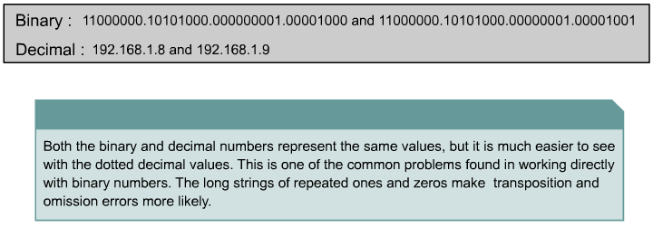
Using dotted decimal allows number patterns to be more easily understood. Both the binary and decimal numbers in Figure represent the same values, but it is easier to see in dotted decimal notation. This is one of the common problems found in working directly with binary number. The long strings of repeated ones and zeros make transposition and omission errors more likely.
It is easy to see the relationship between the numbers 192.168.1.8 and 192.168.1.9, where 11000000.10101000.00000001.00001000 and 11000000.10101000.00000001.00001001 are not as easy to recognize. Looking at the binary, it is almost impossible to see that they are consecutive numbers.
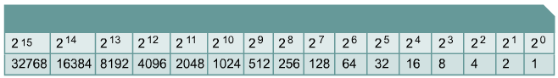

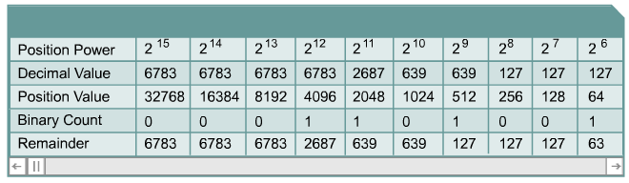
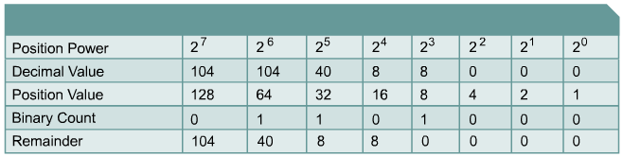

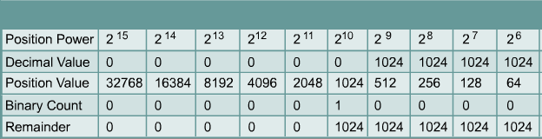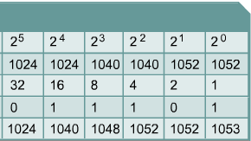

There are many ways to solve a problem. There are also several ways to convert decimal numbers to binary numbers. One method is presented here, however it is not the only method. The student may find other methods easier. It is a matter of personal preference.
When converting a decimal number to binary, the biggest power of two that will fit into the decimal number must be determined. If this process is designed to be working with computers, the most logical place to start is with the largest values that will fit into a byte or two bytes. As mentioned earlier, the most common grouping of bits is eight, which make up one byte. However, sometimes the largest value that can be held in one byte is not large enough for the values needed. To accommodate this, bytes are combined. Instead of having two eight-bit numbers, one 16-bit number is created. Instead of three eight-bit numbers, one 24-bit number is created. The same rules apply as they did for eight-bit numbers. Multiply the previous position value by two to get the present column value.
Since working with computers often is referenced by bytes it is easiest to start with byte boundaries and calculate from there. Start by calculating a couple of examples, the first being 6,783. Since this number is greater than 255, the largest value possible in a single byte, two bytes will be used. Start calculating from 2¹⁵. The binary equivalent of 6,783 is 00011010 01111111.
The second example is 104. Since this number is less than 255, it can be represented by one byte. The binary equivalent of 104 is 01101000.
This method works for any decimal number. Consider the decimal number one million. Since one million is greater than the largest value that can be held in two bytes, 65535, at least three bytes will be needed. By multiplying by two until 24 bits, three bytes, is reached, the value will be 8,388,608. This means that the largest value that 24 bits can hold is 16,777,215. So starting at the 24-bit, follow the process until zero is reached. Continuing with the procedure described, it is determined that the decimal number one million is equal to the binary number 00001111 01000010 01000000.
Figure includes some decimal to binary conversion exercises.
Binary to decimal conversion is just the opposite. Simply place the binary in the table and if there is a one in a column position add that value into the total. Convert 00000100 00011101 to decimal. The answer is 1053.
Figure includes some decimal to binary conversion exercises
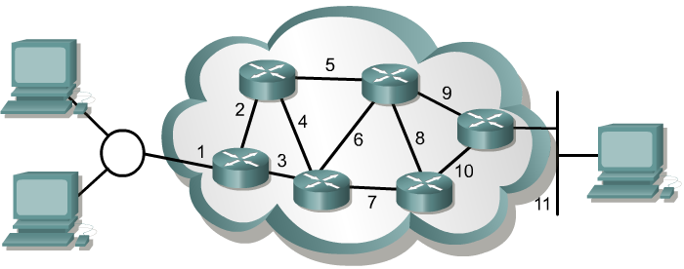

A router forwards packets from the originating network to the destination network using the IP protocol. The packets must include an identifier for both the source and destination networks. Using the IP address of destination network, a router can deliver a packet to the correct network. When the packet arrives at a router connected to the destination network, the router uses the IP address to locate the particular computer connected to that network. This system works in much the same way as the national postal system. When the mail is routed, it must first be delivered to the post office at the destination city using the zip code. That post office then must locate the final destination in that city using the street address. This is a two-step process.

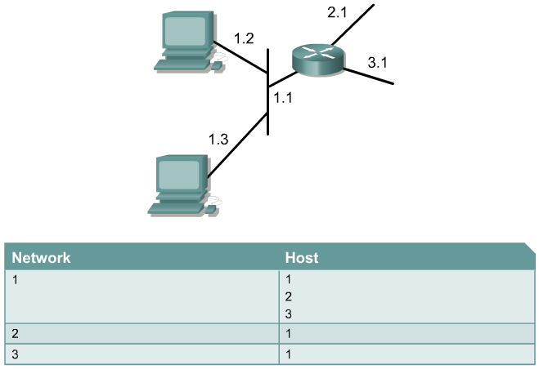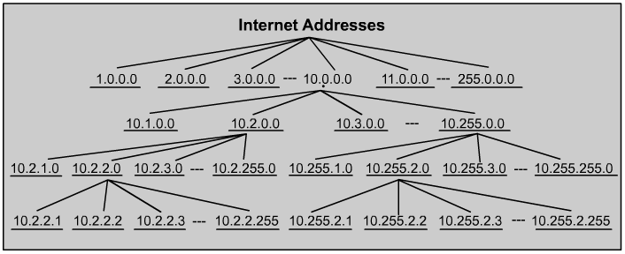Accordingly, every IP address has two parts. One part identifies the network where the system is connected, and a second part identifies that particular system on the network. As is shown Figure , each octet ranges from 0 to 255. Each one of the octets breaks down into 256 subgroups and they break down into another 256 subgroups with 256 addresses in each. By referring to the group address directly above a group in the hierarchy, all of the groups that branch from that address can be referenced as a single unit.
This kind of address is called a hierarchical address, because it contains different levels. An IP address combines these two identifiers into one number. This number must be a unique number, because duplicate addresses would make routing impossible. The first part identifies the system's network address. The second part, called the host part, identifies which particular machine it is on the network.
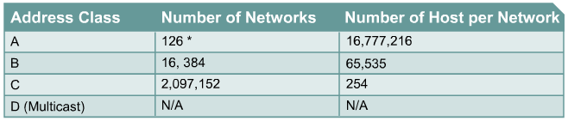
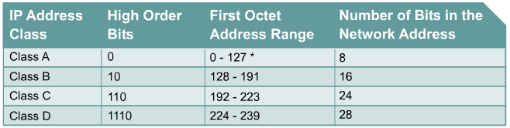
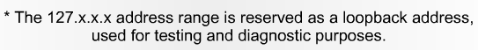
IP addresses are divided into classes to define the large, medium, and small networks. Class A addresses are assigned to larger networks. Class B addresses are used for medium-sized networks, and Class C for small networks. The first step in determining which part of the address identifies the network and which part identifies the host is identifying the class of an IP address.
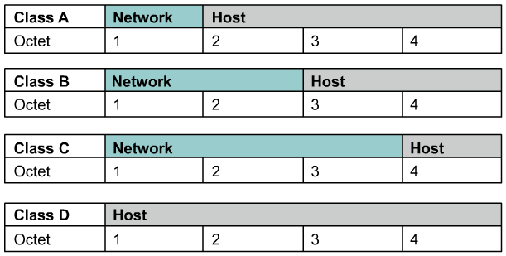
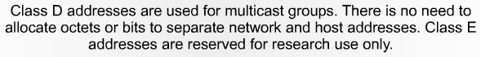

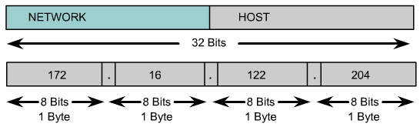
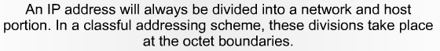
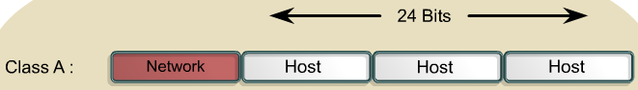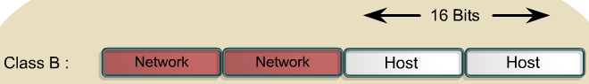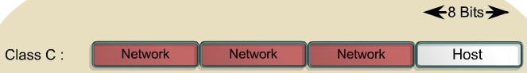

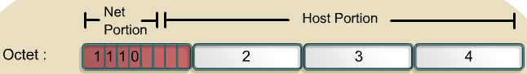

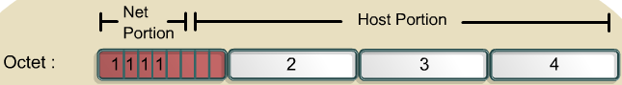

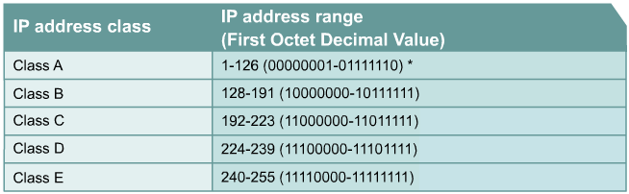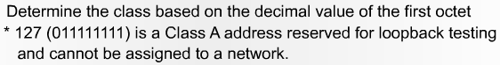

To accommodate different size networks and aid in classifying these networks, IP addresses are divided into groups called classes. This is known as classful addressing. Each complete 32-bit IP address is broken down into a network part and a host part. A bit or bit sequence at the start of each address determines the class of the address. There are five IP address classes as shown in Figure .
The Class A address was designed to support extremely large networks, with more than 16 million host addresses available. Class A IP addresses use only the first octet to indicate the network address. The remaining three octets provide for host addresses.
The first bit of a Class A address is always 0. With that first bit a 0, the lowest number that can be represented is 00000000, decimal 0. The highest number that can be represented is 01111111, decimal 127. The numbers 0 and 127 are reserved and cannot be used as network addresses. Any address that starts with a value between 1 and 126 in the first octet is a Class A address.
The 127.0.0.0 network is reserved for loopback testing. Routers or local machines can use this address to send packets back to themselves. Therefore, this number cannot be assigned to a network.
The Class B address was designed to support the needs of moderate to large-sized networks. A Class B IP address uses the first two of the four octets to indicate the network address. The other two octets specify host addresses.
The first two bits of the first octet of a Class B address are always 10. The remaining six bits may be populated with either 1s or 0s. Therefore, the lowest number that can be represented with a Class B address is 10000000, decimal 128. The highest number that can be represented is 10111111, decimal 191. Any address that starts with a value in the range of 128 to 191 in the first octet is a Class B address.
The Class C address space is the most commonly used of the original address classes. This address space was intended to support small networks with a maximum of 254 hosts.
A Class C address begins with binary 110. Therefore, the lowest number that can be represented is 11000000, decimal 192. The highest number that can be represented is 11011111, decimal 223. If an address contains a number in the range of 192 to 223 in the first octet, it is a Class C address.
The Class D address class was created to enable multicasting in an IP address. A multicast address is a unique network address that directs packets with that destination address to predefined groups of IP addresses. Therefore, a single station can simultaneously transmit a single stream of data to multiple recipients.
The Class D address space, much like the other address spaces, is mathematically constrained. The first four bits of a Class D address must be 1110. Therefore, the first octet range for Class D addresses is 11100000 to 11101111, or 224 to 239. An IP address that starts with a value in the range of 224 to 239 in the first octet is a Class D address.
A Class E address has been defined. However, the Internet Engineering Task Force (IETF) reserves these addresses for its own research. Therefore, no Class E addresses have been released for use in the Internet. The first four bits of a Class E address are always set to 1s. Therefore, the first octet range for Class E addresses is 11110000 to 11111111, or 240 to 255.
Figure shows the IP address range of the first octet both in decimal and binary for each IP address class.
Lab Exercise: IP Addressing Basics This lab is to name the five different classes of IP addresses and to describe the characteristics and use of the different IP address classes.

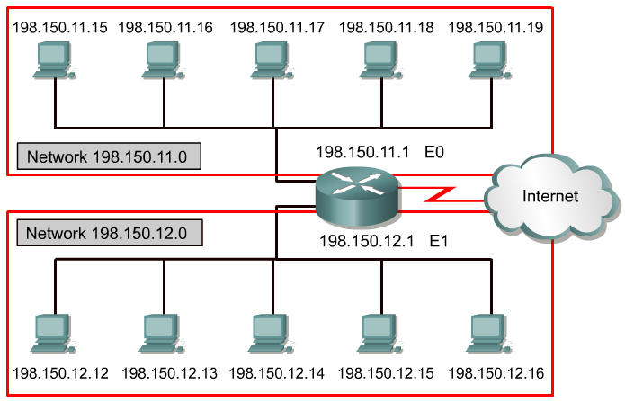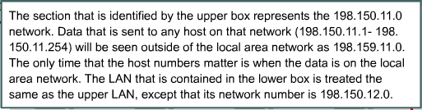

Certain host addresses are reserved and cannot be assigned to devices on a network. These reserved host addresses include the following:
- Network address – Used to identify the network itself
In Figure , the section that is identified by the upper box represents the 198.150.11.0 network. Data that is sent to any host on that network (198.150.11.1- 198.150.11.254) will be seen outside of the local area network as 198.159.11.0. The only time that the host numbers matter is when the data is on the local area network. The LAN that is contained in the lower box is treated the same as the upper LAN, except that its network number is 198.150.12.0.
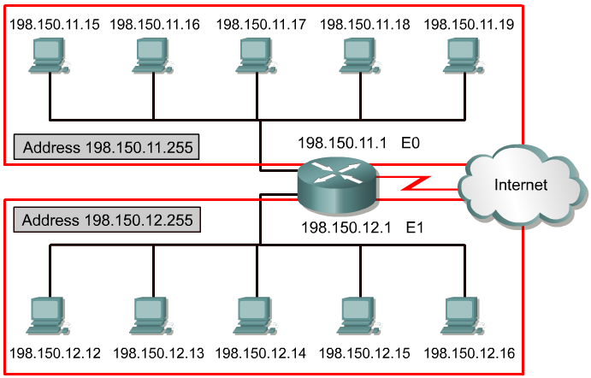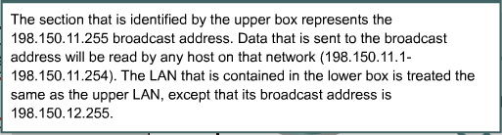
- Broadcast address – Used for broadcasting packets to all the devices on a network
In Figure , the section that is identified by the upper box represents the 198.150.11.255 broadcast address. Data that is sent to the broadcast address will be read by all hosts on that network (198.150.11.1- 198.150.11.254). The LAN that is contained in the lower box is treated the same as the upper LAN, except that its broadcast address is 198.150.12.255.
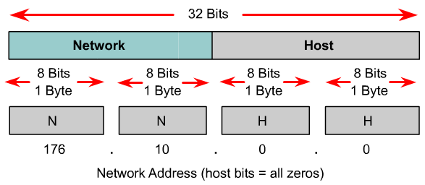
An IP address that has binary 0s in all host bit positions is reserved for the network address. In a Class A network example, 113.0.0.0 is the IP address of the network, known as the network ID, containing the host 113.1.2.3. A router uses the network IP address when it forwards data on the Internet. In a Class B network example, the address 176.10.0.0 is a network address, as shown in Figure .
In a Class B network address, the first two octets are designated as the network portion. The last two octets contain 0s because those 16 bits are for host numbers and are used to identify devices that are attached to the network. The IP address, 176.10.0.0, is an example of a network address. This address is never assigned as a host address. A host address for a device on the 176.10.0.0 network might be 176.10.16.1. In this example, “176.10” is the network portion and “16.1” is the host portion
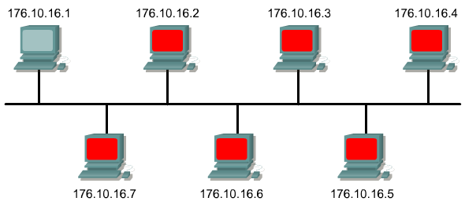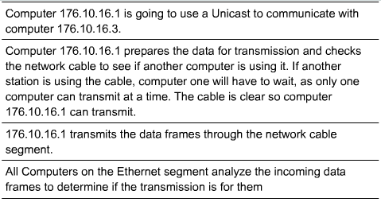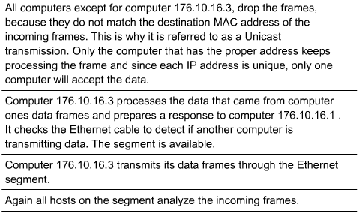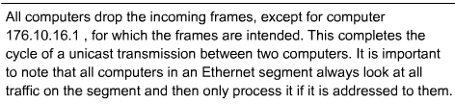
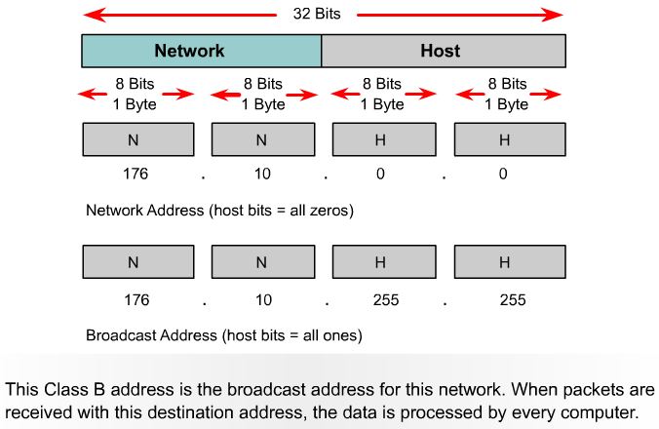

To send data to all the devices on a network, a broadcast address is needed. A broadcast occurs when a source sends data to all devices on a network. To ensure that all the other devices on the network process the broadcast, the sender must use a destination IP address that they can recognize and process. Broadcast IP addresses end with binary 1s in the entire host part of the address.
In the network example, 176.10.0.0, the last 16 bits make up the host field or host part of the address. The broadcast that would be sent out to all devices on that network would include a destination address of 176.10.255.255. This is because 255 is the decimal value of an octet containing 11111111.
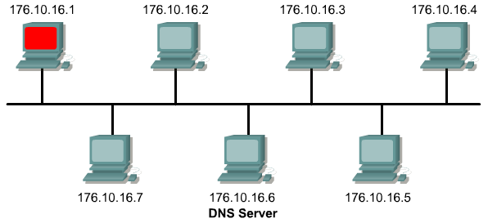
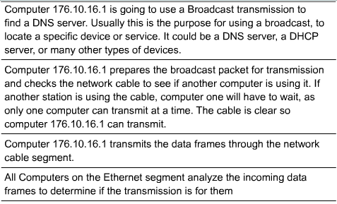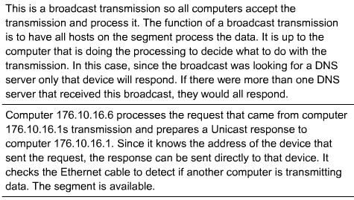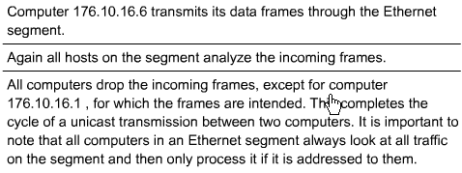
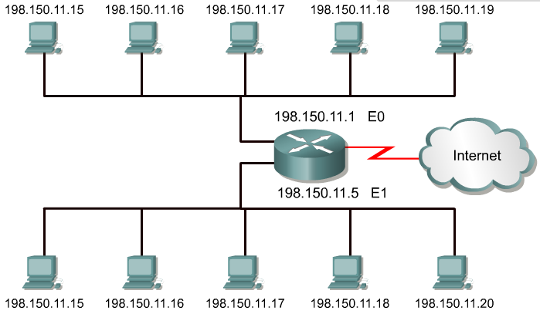
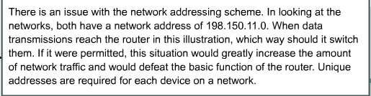

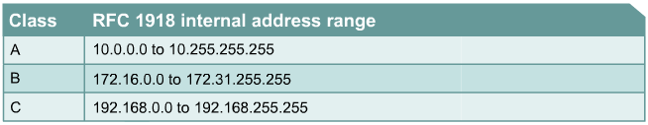

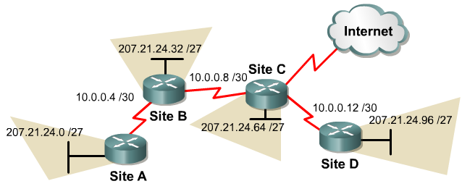

The stability of the Internet depends directly on the uniqueness of publicly used network addresses. In Figure , there is an issue with the network addressing scheme. In looking at the networks, both have a network address of 198.150.11.0. The router in this illustration will not be able to forward the data packets correctly. Duplicate network IP addresses prevent the router from performing its job of best path selection. Unique addresses are required for each device on a network.
A procedure was needed to make sure that addresses were in fact unique. Originally, an organization known as the Internet Network Information Center (InterNIC) handled this procedure. InterNIC no longer exists and has been succeeded by the Internet Assigned Numbers Authority (IANA). IANA carefully manages the remaining supply of IP addresses to ensure that duplication of publicly used addresses does not occur. Duplication would cause instability in the Internet and compromise its ability to deliver datagrams to networks.
Public IP addresses are unique. No two machines that connect to a public network can have the same IP address because public IP addresses are global and standardized. All machines connected to the Internet agree to conform to the system. Public IP addresses must be obtained from an Internet service provider (ISP) or a registry at some expense.
With the rapid growth of the Internet, public IP addresses were beginning to run out. New addressing schemes, such as classless interdomain routing (CIDR) and IPv6 were developed to help solve the problem. CIDR and IPv6 are discussed later in the course.
Private IP addresses are another solution to the problem of the impending exhaustion of public IP addresses. As mentioned, public networks require hosts to have unique IP addresses. However, private networks that are not connected to the Internet may use any host addresses, as long as each host within the private network is unique. Many private networks exist alongside public networks. However, a private network using just any address is strongly discouraged because that network might eventually be connected to the Internet. RFC 1918 sets aside three blocks of IP addresses for private, internal use. These three blocks consist of one Class A, a range of Class B addresses, and a range of Class C addresses. Addresses that fall within these ranges are not routed on the Internet backbone. Internet routers immediately discard private addresses. If addressing a nonpublic intranet, a test lab, or a home network, these private addresses can be used instead of globally unique addresses. Private IP addresses can be intermixed, as shown in the graphic, with public IP addresses. This will conserve the number of addresses used for internal connections.
Connecting a network using private addresses to the Internet requires translation of the private addresses to public addresses. This translation process is referred to as Network Address Translation (NAT). A router usually is the device that performs NAT. NAT, along with CIDR and IPv6 are covered in more depth later in the curriculum.
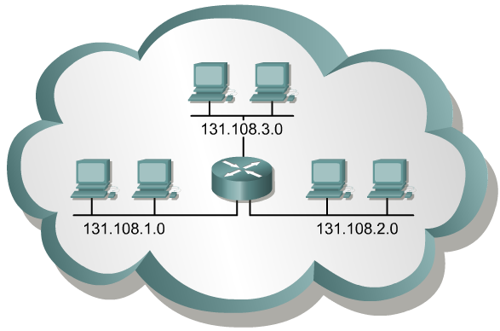

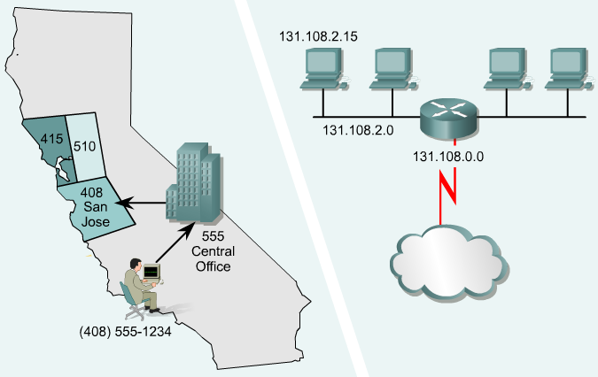

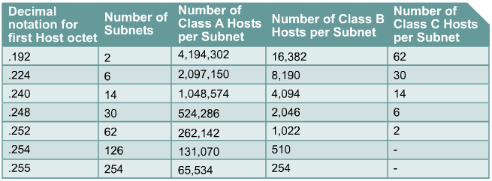

Subnetting is another method of managing IP addresses. This method of dividing full network address classes into smaller pieces has prevented complete IP address exhaustion. It is impossible to cover TCP/IP without mentioning subnetting. As a system administrator it is important to understand subnetting as a means of dividing and identifying separate networks throughout the LAN. It is not always necessary to subnet a small network. However, for large or extremely large networks, subnetting is required. Subnetting a network means to use the subnet mask to divide the network and break a large network up into smaller, more efficient and manageable segments, or subnets. An example would be the U.S. telephone system which is broken into area codes, exchange codes, and local numbers.
The system administrator must resolve these issues when adding and expanding the network. It is important to know how many subnets or networks are needed and how many hosts will be needed on each network. With subnetting, the network is not limited to the default Class A, B, or C network masks and there is more flexibility in the network design.
Subnet addresses include the network portion, plus a subnet field and a host field. The subnet field and the host field are created from the original host portion for the entire network. The ability to decide how to divide the original host portion into the new subnet and host fields provides addressing flexibility for the network administrator.
To create a subnet address, a network administrator borrows bits from the host field and designates them as the subnet field. The minimum number of bits that can be borrowed is two. When creating a subnet, where only one bit was borrowed the network number would be the .0 network. The broadcast number would then be the .255 network. The maximum number of bits that can be borrowed can be any number that leaves at least two bits remaining, for the host number.
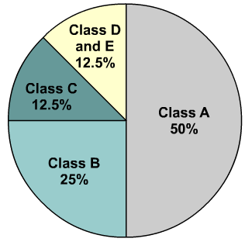

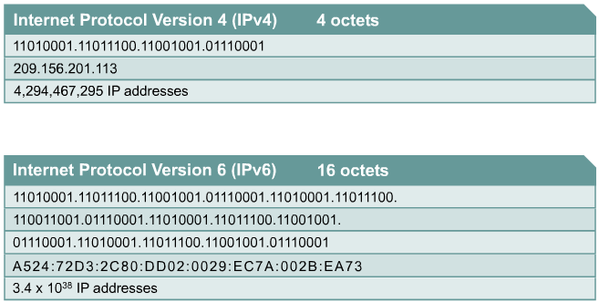

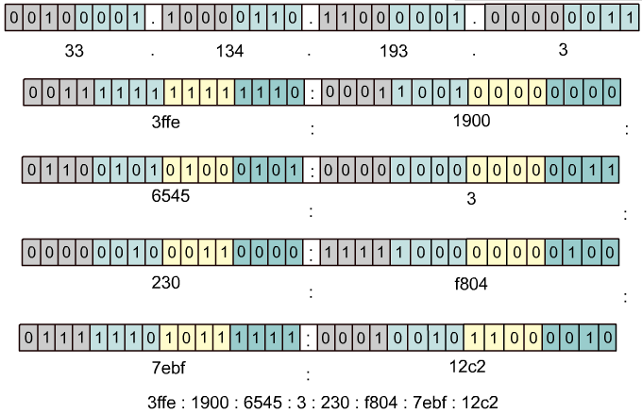

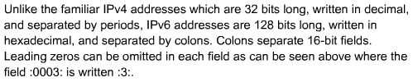
When TCP/IP was adopted in the 1980s, it relied on a two-level addressing scheme. At the time this offered adequate scalability. Unfortunately, the designers of TCP/IP could not have predicted that their protocol would eventually sustain a global network of information, commerce, and entertainment. Over twenty years ago, IP Version 4 (IPv4) offered an addressing strategy that, although scalable for a time, resulted in an inefficient allocation of addresses.
The Class A and B addresses make up 75 percent of the IPv4 address space, however fewer than 17,000 organizations can be assigned a Class A or B network number. Class C network addresses are far more numerous than Class A and Class B addresses, although they account for only 12.5 percent of the possible four billion IP addresses.
Unfortunately, Class C addresses are limited to 254 usable hosts. This does not meet the needs of larger organizations that cannot acquire a Class A or B address. Even if there were more Class A, B, and C addresses, too many network addresses would cause Internet routers to come to a stop under the burden of the enormous size of routing tables required to store the routes to reach each of the networks.
As early as 1992, the Internet Engineering Task Force (IETF) identified the following two specific concerns:
- Exhaustion of the remaining, unassigned IPv4 network addresses. At the time, the Class B space was on the verge of depletion.
- The rapid and large increase in the size of Internet routing tables occurred as more Class C networks came online. The resulting flood of new network information threatened the ability of Internet routers to cope effectively.
Over the past two decades, numerous extensions to IPv4 have been developed. These extensions are specifically designed to improve the efficiency with which the 32-bit address space can be used. Two of the more important of these are subnet masks and classless interdomain routing (CIDR), which are discussed in more detail in later lessons.
Meanwhile, an even more extendible and scalable version of IP, IP Version 6 (IPv6), has been defined and developed. IPv6 uses 128 bits rather than the 32 bits currently used in IPv4. IPv6 uses hexadecimal numbers to represent the 128 bits. IPv6 provides 640 sextrillion addresses. This version of IP should provide enough addresses for future communication needs. Figure shows IPv4 addresses which are 32 bits long, written in decimal form, and separated by periods. IPv6 addresses are 128 bits long, written in hexadecimal form, and separated by colons. IPv6 fields are 16 bits long. To make the addresses easier to read, leading zeros can be omitted from each field. The field :0003: is written :3:. IPv6 shorthand representation of the 128 bits uses eight 16-bit numbers, shown as four hexadecimal digits.
After years of planning and development, IPv6 is slowly being implemented in select networks. Eventually, IPv6 may replace IPv4 as the dominant Internet protocol.
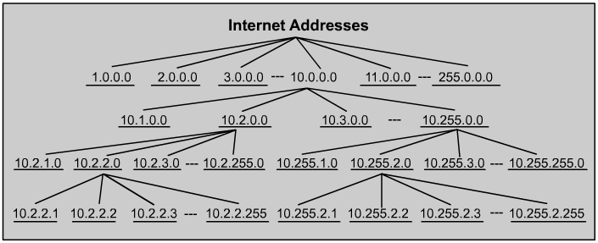
A network host needs to obtain a globally unique address in order to function on the Internet. The physical or MAC address that a host has is only locally significant, identifying the host within the local area network. Since this is a Layer 2 address, the router does not use it to forward outside the LAN.
IP addresses are the most commonly used addresses for Internet communications. This protocol is a hierarchical addressing scheme that allows individual addresses to be associated together and treated as groups. These groups of addresses allow efficient transfer of data across the Internet.
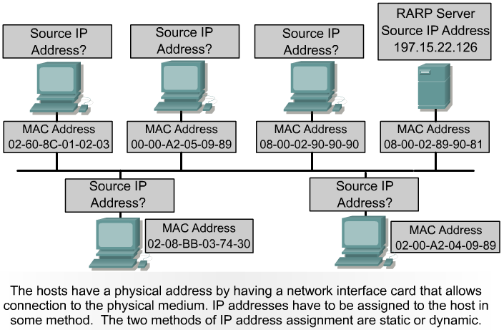

Network administrators use two methods to assign IP addresses. These methods are static and dynamic. Later in this lesson, static addressing and three variations of dynamic addressing will be covered. Regardless of which addressing scheme is chosen, no two interfaces can have the same IP address. Two hosts that have the same IP address could create a conflict that might cause both of the hosts involved not to operate properly. As shown in Figure , the hosts have a physical address by having a network interface card that allows connection to the physical medium.
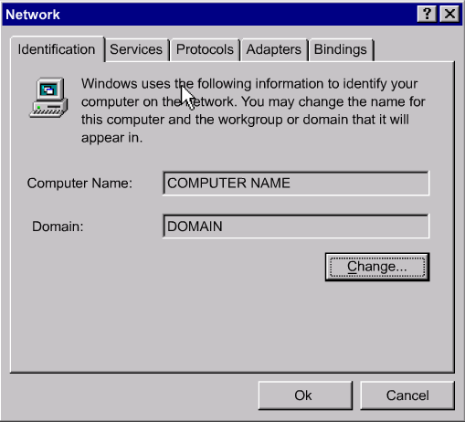

Static assignment works best on small, infrequently changing networks. The system administrator manually assigns and tracks IP addresses for each computer, printer, or server on the intranet. Good recordkeeping is critical to prevent problems which occur with duplicate IP addresses. This is possible only when there are a small number of devices to track.
Servers should be assigned a static IP address so workstations and other devices will always know how to access needed services. Consider how difficult it would be to phone a business that changed its phone number every day.
Other devices that should be assigned static IP addresses are network printers, application servers, and routers.

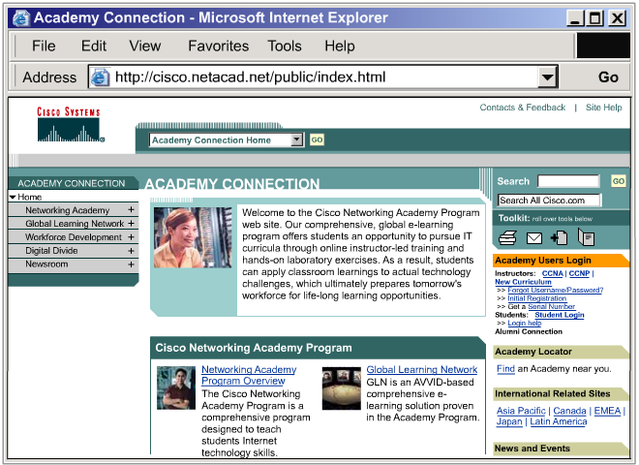
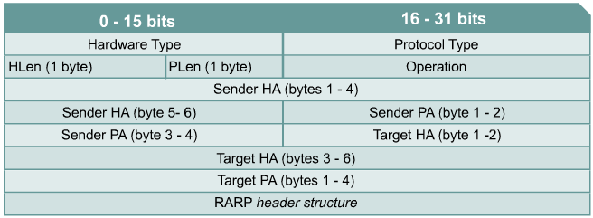
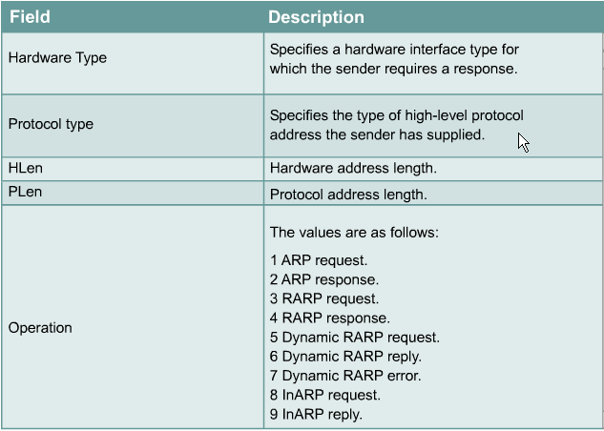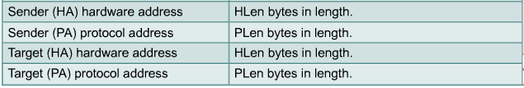

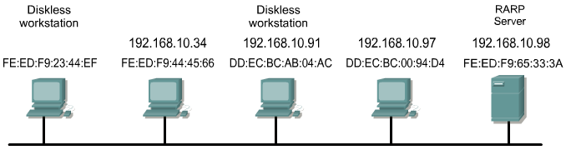

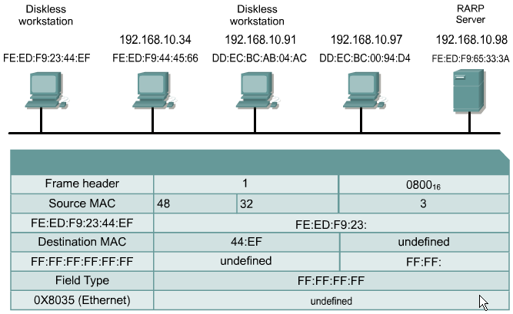

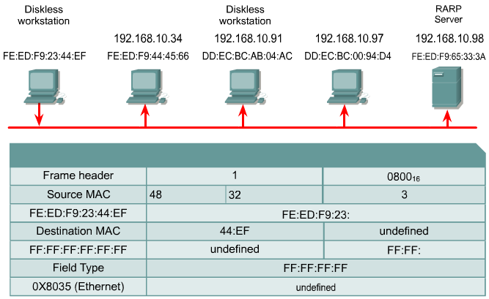

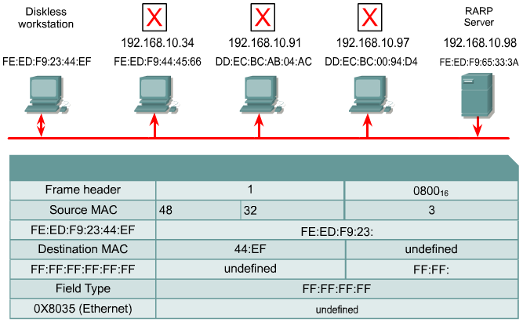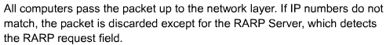
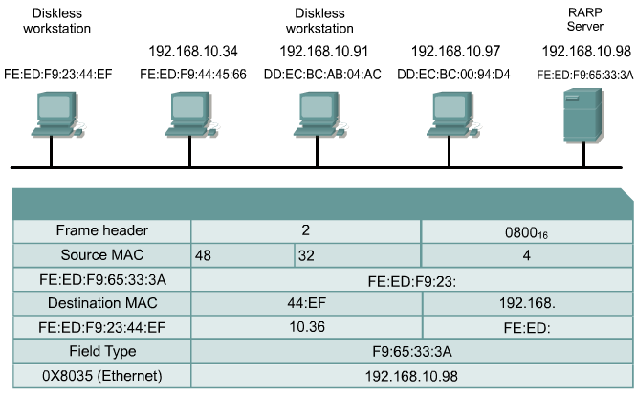

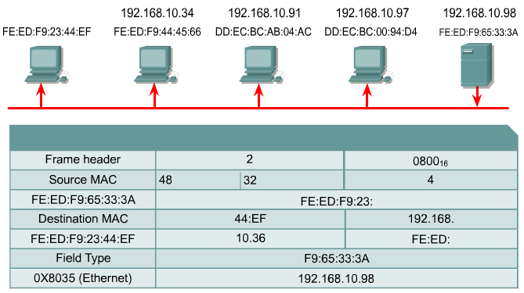
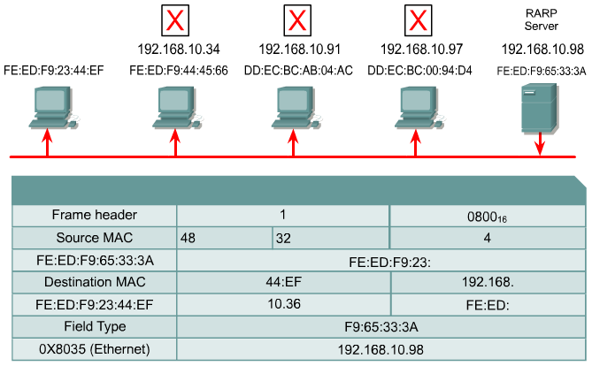

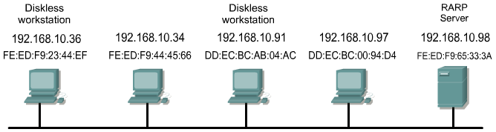

Reverse Address Resolution Protocol (RARP) associates a known MAC addresses with an IP addresses. This association allows network devices to encapsulate data before sending the data out on the network. A network device, such as a diskless workstation, might know its MAC address but not its IP address. RARP allows the device to make a request to learn its IP address. Devices using RARP require that a RARP server be present on the network to answer RARP requests.
Consider an example where a source device wants to send data to another device. In this example, the source device knows its own MAC address but is unable to locate its own IP address in the ARP table. The source device must include both its MAC address and IP address in order for the destination device to retrieve data, pass it to higher layers of the OSI model, and respond to the originating device. Therefore, the source initiates a process called a RARP request. This request helps the source device detect its own IP address. RARP requests are broadcast onto the LAN and are responded to by the RARP server which is usually a router.
RARP uses the same packet format as ARP. However, in a RARP request, the MAC headers and "operation code" are different from an ARP request. The RARP packet format contains places for MAC addresses of both the destination and source devices. The source IP address field is empty. The broadcast goes to all devices on the network. Therefore, the destination MAC address will be set to all binary 1s. Workstations running RARP have codes in ROM that direct them to start the RARP process. A step-by-step layout of the RARP process is illustrated in Figures through .
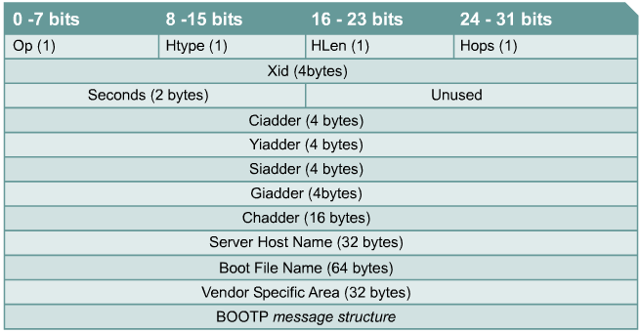

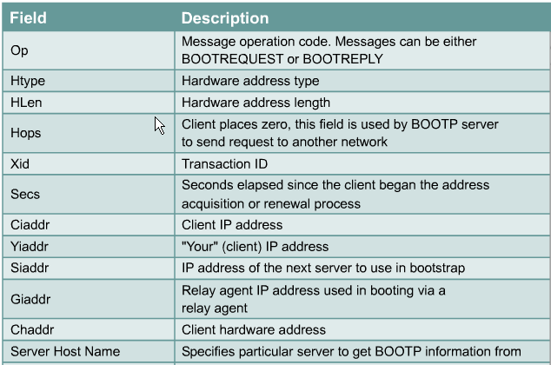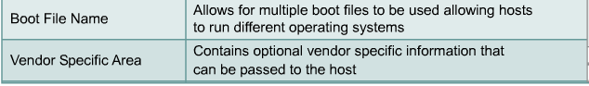
The bootstrap protocol (BOOTP) operates in a client-server environment and only requires a single packet exchange to obtain IP information. However, unlike RARP, BOOTP packets can include the IP address, as well as the address of a router, the address of a server, and vendor-specific information

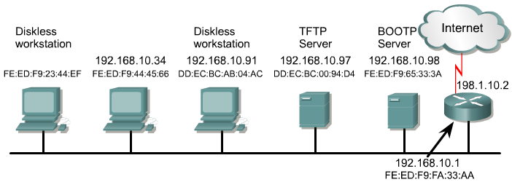

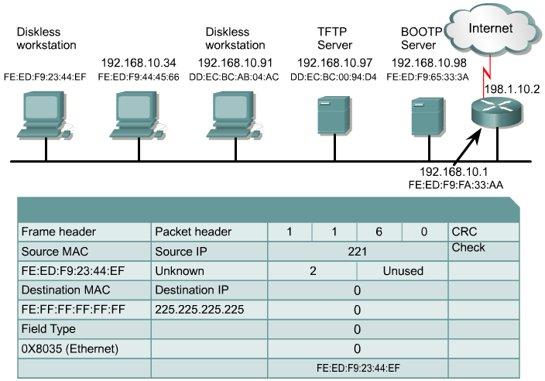
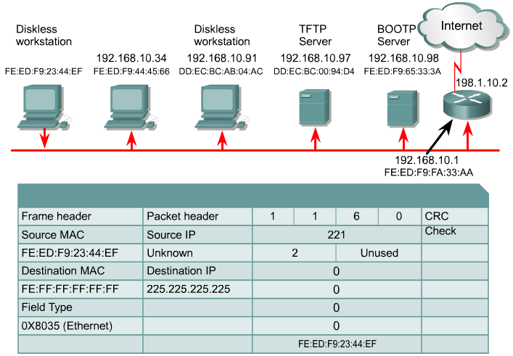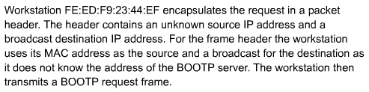
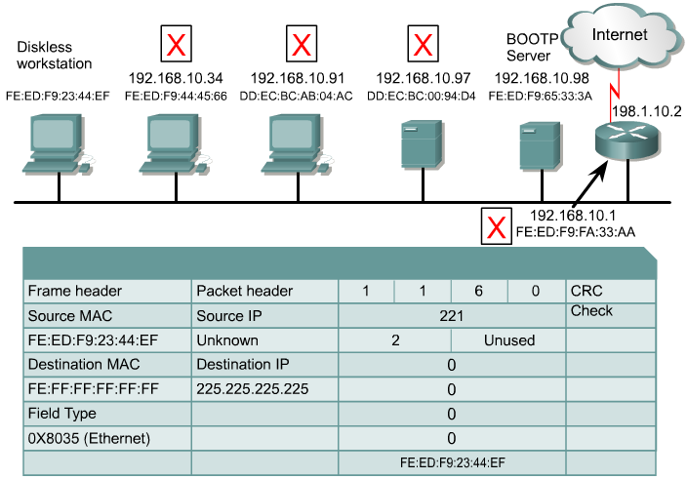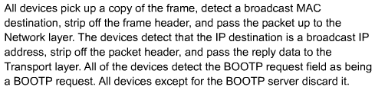

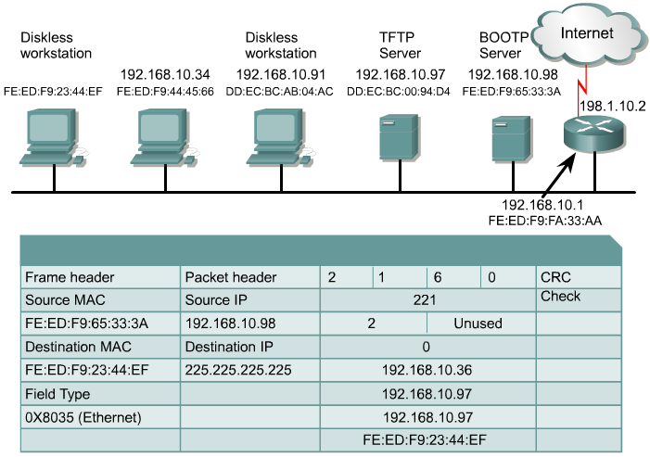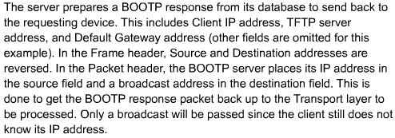

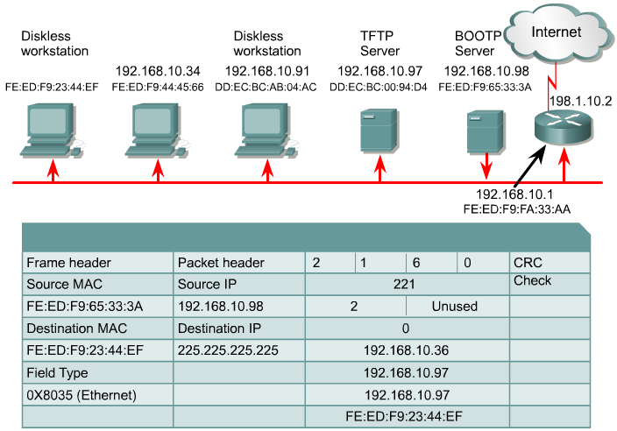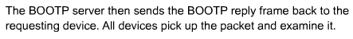

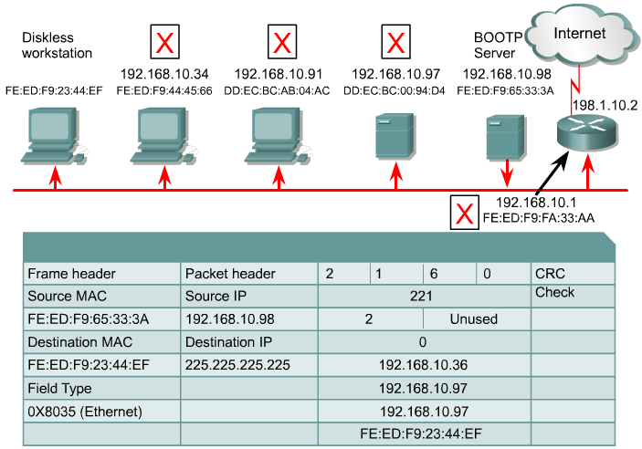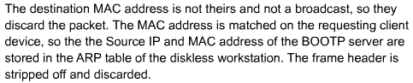

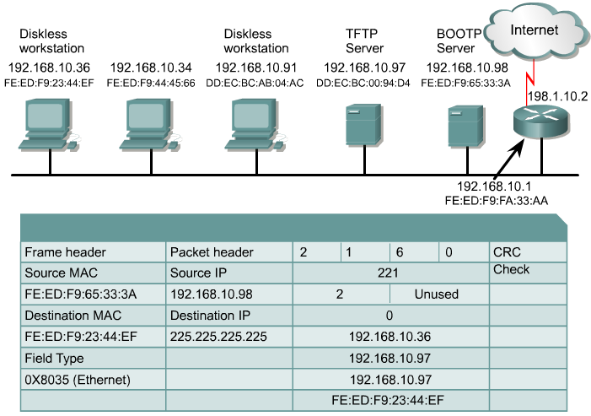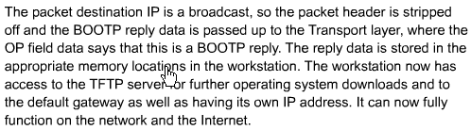
One problem with BOOTP, however, is that it was not designed to provide dynamic address assignment. With BOOTP, a network administrator creates a configuration file that specifies the parameters for each device. The administrator must add hosts and maintain the BOOTP database. Even though the addresses are dynamically assigned, there is still a one to one relationship between the number of IP addresses and the number of hosts. This means that for every host on the network there must be a BOOTP profile with an IP address assignment in it. No two profiles can have the same IP address. Those profiles might be used at the same time and that would mean that two hosts have the same IP address.
A device uses BOOTP to obtain an IP address when starting up. BOOTP uses UDP to carry messages. The UDP message is encapsulated in an IP packet. A computer uses BOOTP to send a broadcast IP packet using a destination IP address of all 1s, 255.255.255.255 in dotted decimal notation. A BOOTP server receives the broadcast and then sends back a broadcast. The client receives a frame and checks the MAC address. If the client finds its own MAC address in the destination address field and a broadcast in the IP destination field, it takes and stores the IP address and other information supplied in the BOOTP reply message. A step-by-step description of the process is shown in Figures through

