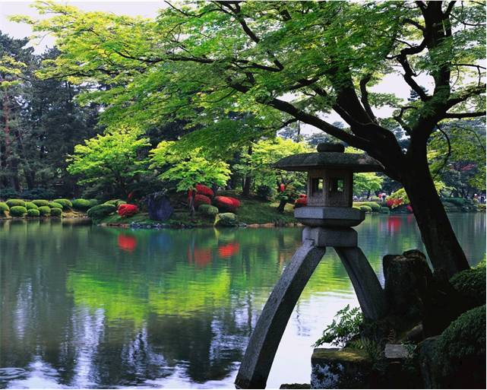

The shady areas of the garden require plants that thrive under such conditions. Before selecting plants, it's important to assess *how* shady the area is—does it get just a few hours of sunlight per day? No sun at all? Does it receive more sun during certain seasons of the year than others? The answers to these questions will help you select the best plants for the area.

The United States National Arboretum has a special section on shade gardens. In addition to several types of grasses, the following are some of the best plants for areas that are in full shade:

**Monkshood**—Tall with sharp clusters of blue flowers

**Bugleweed**—Bronze-purple foliage and fills large areas quickly

**Lily of the Valley**—Fragrant white bell-shaped flowers that are followed by glossy red berries

**Bunchberry**—Green leaves with tiny white clusters of flowers

**Bleeding Heart**—Flowers are tiny pink or white heart shapes with drops at the bottom

**Shooting Star**—Can reach up to 25 inches; has white, pink, or lavender flowers

**Hosta**—Wide range of shapes, colors, and sizes

**Christmas Rose**—Blooms from late fall to early spring; shiny, dark green leathery leaves and white flowers

**Cardinal Flower**—Two to four feet tall, beautiful red flowers

**Bluebells**—Bloom in spring, lavender-blue flowers

**Star Jasmine**—Evergreen vine with perfumed white star-shaped blooms

**Astilbe**—Long-blooming plume-like flowers in shades of white, pink, and red